


DEVELOPMENT OF AI, ML AND CHATBOT POWERED INTERACTIVE ROBOT MASCOT FOR NAMAMI GANGE CONNECT

A PROJECT REPORT

Submitted by
KAUSTHUB K- 20221CSE0166
AYUSH RUSHI K R- 20221CSE0133
NISHITH V- 20221CSE0165

Under the guidance of,
Ms. Bhuvaneshwari Patil

BACHELOR OF TECHNOLOGY

IN

COMPUTER SCIENCE AND ENGINEERING

PRESIDENCY UNIVERSITY
BENGALURU DECEMBER 2025



PRESIDENCY SCHOOL OF COMPUTER SCIENCE AND ENGINEERING
BONAFIDE CERTIFICATE

Certified that this report “AI Chatbot Powered Namami Gange Mascot (Chacha Chaudary)” is a bonafide work of “K KAUSTHUB(20221CSE0166), NISHITH(20221CSE0165), AYUSH RUSHI K R(20221CSE0133)”, who have successfully carried out the project work and submitted the report for partial fulfilment of the requirements for the award of the degree of BACHELOR OF TECHNOLOGY in COMPUTER SCIENCE ENGINEERING during 2025-26.

Ms Bhuvaneshwari Patil  Project Guide  Presidency School of Computer Science and Engineering  Presidency University | Dr. Blessed Prince  Head of the Department Presidency School of Computer Science and Engineering  Presidency University | Dr. Shakkeera L Associate Dean  Presidency School of Computer Science and Engineering  Presidency University | Dr. Duraipandian N  Dean  PSCS & PSIS  Presidency University

Name and Signature of the Examiners

1)
2)

PRESIDENCY UNIVERSITY

PRESIDENCY SCHOOL OF COMPUTER SCIENCE AND ENGINEERING
DECLARATION

We the students of final year B.Tech in COMPUTER SCIENCE ENGINEERING, CYBER SECURITY at Presidency University, Bengaluru, named KAUSTHUB K, NISHITH V, AYUSH RUSHI K R, hereby declare that the project work titled “DEVELOPMENT OF AI, ML AND CHATBOT POWERED INTERACTIVE ROBOT MASCOT FOR NAMAMI GANGE CONNECT” has been independently carried out by us and submitted in partial fulfillment for the award of the degree of B.Tech in COMPUTER SCIENCE ENGINEERING during the academic year of 2025-26. Further, the matter embodied in the project has not been submitted previously by anybody for the award of any Degree or Diploma to any other institution.

KAUSTHUB K USN: 20221CSE0166
AYUSHRUSHI KR USN: 20221CSE0133
NISHITH V USN: 20221CSE0165
PLACE: BENGALURU
DATE: 26th-December 2025
ACKNOWLEDGEMENT

For completing this project work, We/I have received the support and the guidance from many people whom I would like to mention with deep sense of gratitude and indebtedness. We extend our gratitude to our beloved Chancellor, Pro-Vice Chancellor, and Registrar for their support and encouragement in completion of the project.
I would like to sincerely thank my internal guide Dr./Mr/Ms Dr. Sampath A K, Professor, Presidency School of Computer Science and Engineering, Presidency University, for his/her moral support, motivation, timely guidance and encouragement provided to us during the period of our project work.
I am also thankful to Dr. Anandaraj, Professor, Head of the Department, Presidency School of Computer Science and Engineering Presidency University, for his mentorship and encouragement.
We express our cordial thanks to Dr. Duraipandian N, Dean PSCS & PSIS, Dr. Shakkeera L, Associate Dean, Presidency School of computer Science and Engineering and the Management of Presidency University for providing the required facilities and intellectually stimulating environment that aided in the completion of my project work.
We are grateful to Dr. Sampath A K, and Dr. Geetha A, PSCS Project Coordinators, Dr. Sharmast vali, Program Project Coordinator, Presidency School of Computer Science and Engineering, or facilitating problem statements, coordinating reviews, monitoring progress, and providing their valuable support and guidance.
We are also grateful to Teaching and Non-Teaching staff of Presidency School of Computer Science and Engineering and also staff from other departments who have extended their valuable help and cooperation.
KAUSTHUB K
NISHITH V
AYUSH RUSHI K R
Abstract

The Namami Gange Programme, launched in 2014, focuses on pollution abatement and conservation of the Ganga River. Public awareness and participation are crucial for its long-term success. Chacha Chaudhary was declared the mascot in October 2021 to enhance youth engagement. This project leverages AI capabilities, including Natural Language Processing (NLP) for real-time conversational interactions, Machine Learning (ML) for adaptive responses and personalization, and Speech Synthesis (Text-to-Speech - TTS) and Automatic Speech Recognition (ASR) for natural voice-based interactions.
The Namami Gange Programme, initiated in 2014, is a flagship conservation effort by the Government of India with the dual objectives of effective abatement of pollution and the conservation and rejuvenation of the National River Ganga. Recognizing that governmental efforts alone are insufficient for such a colossal undertaking, the program places significant emphasis on fostering public awareness and ensuring widespread community participation. These elements are deemed crucial for the long-term sustainability and ultimate success of the program.

To enhance youth engagement and make the program more relatable to a younger demographic, Chacha Chaudhary, an iconic Indian comic book character, was officially declared the mascot of the Namami Gange Programme in October 2021. This strategic move aims to leverage the character's popularity to disseminate messages about river conservation and pollution prevention among children and adolescents, encouraging their active involvement.

This particular project further augments these efforts by strategically integrating advanced Artificial Intelligence (AI) capabilities. This multi-faceted AI approach includes:
- Natural Language Processing (NLP): NLP capabilities are being utilized to facilitate real-time conversational interactions. This allows for dynamic and intuitive communication, potentially through chatbots or virtual assistants, providing immediate answers to queries about the Namami Gange Programme, its objectives, and ways to participate.
- Machine Learning (ML): ML algorithms are employed to enable adaptive responses and personalization. By analyzing user interactions and preferences, the system can tailor its communication and information delivery, making the experience more engaging and relevant for individual users. This could involve providing customized information based on location, interests, or previous questions.
- Speech Synthesis (Text-to-Speech - TTS) and Automatic Speech Recognition (ASR): The integration of TTS and ASR technologies is designed to enable natural, voice-based interactions. This allows users to communicate with the system using spoken language, making the program more accessible and user-friendly, particularly for those who may prefer vocal interaction over text-based methods. This also caters to a broader audience,including individuals with varying literacy levels or disabilities.

Table of Content

Sl. No. | Title | Page No.
 | Declaration
 | Acknowledgement
 | Abstract
 | List of Figures
 | List of Tables
 | Abbreviations
1. | Introduction  1.1 Background  1.2 Statistics of project  1.3 Prior existing technologies  1.4 Proposed approach  1.5 Objectives  1.6 SDGs  1.7 Overview of project report
2. | Literature review
3. | Methodology
4. | Project management  4.1 Project timeline  4.2 Risk analysis  4.3 Project budget
5. | Analysis and Design  5.1 Requirements  5.2 Block Diagram  5.3 System Flow Chart  5.4 Choosing devices  5.5 Designing units  5.6 Standards  5.7 Mapping with IoTWF reference model layers  5.8 Domain model specification  5.9 Communication model  5.10 IoT deployment level  5.11 Functional view  5.12 Mapping IoT deployment level with functional view  5.13 Operational view  5.14 Other Design
6. | Hardware, Software and Simulation  6.1 Hardware  6.2 Software development tools  6.3 Software code  6.4 Simulation
7. | Evaluation and Results  7.1 Test points  7.2 Test plan  7.3 Test result  7.4 Insights
8. | Social, Legal, Ethical, Sustainability and Safety Aspects  8.1 Social aspects  8.2 Legal aspects  8.3 Ethical aspects  8.4 Sustainability aspects  8.5 Safety aspects
9. | Conclusion
 | References
 | Base Paper
 | Appendix

Chapter 1
Introduction

Importance of the Ganga River: The Ganga River serves as a vital lifeline for over 400 million individuals, holding profound religious, cultural, and ecological significance.

Challenges: The river faces escalating pollution levels, significant discharge of untreated sewage, and a decline in biodiversity, despite numerous governmental interventions.

Need for Awareness: Infrastructural development alone is insufficient to address these issues; sustainable, long-term change is contingent upon heightened public awareness and proactive engagement.

Rationale for Chacha Chaudhary: This revered Indian comic character, emblematic of wisdom and effective problem-solving, was officially designated as the Namami Gange mascot in 2021.

Project Vision: The project aims to deploy an AI-driven mascot and digital avatar, functioning as a "digital ambassador" to elucidate complex ecological concepts for the general populace.

Objectives:
- To educate citizens on conservation principles through interactive methodologies.
- To facilitate multilingual outreach initiatives.
- To foster behavioral modification among children, youth, and communities.

1.1 Background
- The Namami Gange Programme, launched in 2014 by the Government of India under the Ministry of Jal Shakti, is a flagship initiative for the conservation and rejuvenation of the River Ganga and its tributaries. The programme focuses on pollution abatement, sewerage treatment, riverfront development, afforestation, and public participation. As the river holds immense ecological, economic, and cultural significance, the success of the programme depends not only on infrastructural measures but also on sustained community engagement and behavioral change among citizens [1].
- Recognizing the importance of cultural connect, the National Mission for Clean Ganga (NMCG) partnered with Diamond Toons in October 2021 to appoint Chacha Chaudhary, a popular Indian comic character, as the official mascot of the Namami Gange Programme. Chacha Chaudhary’s persona—depicted as wise, approachable, and solution-oriented—provides a relatable medium to spread awareness among children, youth, and communities regarding river conservation [2].
- In parallel, rapid advances in Artificial Intelligence (AI), Machine Learning (ML), and Conversational Agents have created opportunities for interactive and adaptive public outreach tools. Chatbots and embodied digital avatars have been shown to improve knowledge transfer, sustain user attention, and personalize learning experiences [3], [4]. However, existing systems often suffer from limitations such as rule-based rigidity, lack of multilingual support, and minimal cultural contextualization.
- This project integrates these two dimensions—the cultural icon of Chacha Chaudhary and state-of-the-art AI/ML technologies—to develop an interactive mascot and digital avatar for Namami Gange. By incorporating Natural Language Processing (NLP) for dialogue understanding, Automatic Speech Recognition (ASR) for voice inputs, Text-to-Speech (TTS) for naturalistic responses, and multilingual support, the system aims to build a strong river-people connect. Through kiosks at Ganga museums, online digital avatars, and mobile applications, the project will enable real-time, engaging, and personalized awareness campaigns to strengthen citizen participation in the conservation of the River Ganga.

References (IEEE format)
- [1] National Mission for Clean Ganga (NMCG), Namami Gange Programme Overview, Ministry of Jal Shakti, Government of India, 2014. [Online]. Available: https://nmcg.nic.in
- [2] Press Trust of India, “Chacha Chaudhary to spread awareness on Namami Gange Programme,” The Hindu, Oct. 2021. [Online]. Available: https://www.thehindu.com
- [3] T. Belpaeme, P. Baxter, R. Read, R. Wood, H. Cuayáhuitl, B. Kiefer, S. R. Köse, G. Neumann, M. L. Kenney, and I. Kruijff-Korbayová, “Social robots for education: A review,” Science Robotics, vol. 3, no. 21, pp. 1–12, 2018.
- [4] D. A. Pereira, A. H. Oliveira, and S. G. Carvalho, “The Arizona Water Chatbot: Helping residents navigate water conservation,” Proceedings of the ACM Conference on Conversational Agents, 2024.
1.2 Statistics
The Namami Gange Programme, launched in 2014, aims to abate pollution and conserve the River Ganga. With over 400 million people relying on the Ganga for their livelihoods and cultural practices, the program's success is paramount. Chacha Chaudhary, with a legacy spanning over 50 years and a readership of approximately 100 million, was officially appointed as the mascot in October 2021 to amplify outreach, particularly among the youth and children [Source: National Mission for Clean Ganga, Diamond Toons].

The project addresses the following key statistical and demographic needs:

- Youth Engagement: India has the largest youth population in the world, with over 356 million individuals aged 10-24 years [Source: Ministry of Youth Affairs and Sports, Government of India]. Leveraging Chacha Chaudhary's widespread recognition among this demographic is crucial for fostering early environmental consciousness.
- Literacy and Digital Penetration: While overall literacy rates are improving (77.7% as per NSS 2017-18), digital penetration continues to grow rapidly. As of 2023, India has over 820 million internet subscribers [Source: TRAI]. This project, with its AI-powered digital avatar and chatbot, is designed to reach a significant portion of this digitally connected population.
- Multilingual Outreach: India is home to 22 official languages and hundreds of dialects. The project's emphasis on multilingual support is critical to ensure that conservation messages resonate across diverse linguistic communities along the Ganga basin, which spans across 11 states and supports a population of over 520 million [Source: National Mission for Clean Ganga].
- Impact of Pollution: The Ganga basin generates approximately 12,000 million liters per day (MLD) of wastewater, with only about 4,000 MLD being treated [Source: Central Pollution Control Board]. Increasing public awareness and participation through initiatives like the Chacha Chaudhary mascot project can significantly contribute to reducing untreated sewage discharge and promoting responsible waste management.
- Behavioral Change: Studies indicate that targeted awareness campaigns can lead to a significant reduction in environmentally harmful behaviors. For instance, campaigns focused on waste segregation have shown up to a 30% improvement in compliance rates in urban areas [Source: Environmental Ministry Reports, various cities]. The interactive nature of this project aims to drive similar positive behavioral shifts.

These statistics underscore the critical need for innovative and engaging approaches to public awareness and participation in the Namami Gange Programme, which this AI-driven Chacha Chaudhary mascot project aims to fulfill.

1.3 Prior Existing Technologies
Before the development of this project, several technologies have been used for environmental awareness, interactive learning, and digital engagement. Key prior technologies include:
- Chatbots and Conversational Agents:
Chatbots have been widely used in education, healthcare, and environmental campaigns to provide automated information and interactive guidance. Popular frameworks such as Rasa, Dialogflow, and IBM Watson Assistant allow natural language understanding (NLU) and response generation, enabling users to interact conversationally with digital systems (Fadhil, 2018).
- Digital Avatars and Mascots:
Virtual avatars have been used for educational and engagement purposes to provide a relatable and interactive interface. Examples include AI tutors in e-learning platforms and digital mascots in awareness campaigns. Avatars enhance user engagement and retention by combining visual, textual, and audio interactions (Bailenson et al., 2008).
- AI and Machine Learning in Personalized Learning:
Machine learning algorithms have been employed to adapt content and recommendations according to user behavior. Techniques such as recommendation systems, clustering, and classification help in personalizing learning experiences and improving engagement in educational software (Zhou et al., 2020).
- Gamification and Interactive Platforms:
Gamification strategies like quizzes, badges, and storytelling are used in environmental campaigns and learning platforms to increase user participation. Systems like Khan Academy and environmental awareness apps demonstrate that gamified interactive content improves learning outcomes and motivation (Deterding et al., 2011).
- Environmental Awareness Digital Platforms:
Web and mobile-based platforms have been deployed for river and ecosystem awareness. These include portals for citizen reporting, mobile apps for pollution monitoring, and educational games aimed at encouraging sustainable practices
1.4 Proposed approach

Aim of the Project
The aim of this project is to design and develop a chatbot inspired by the popular Indian comic character Chacha Choudhary. The chatbot will simulate the persona, humor, intelligence, and storytelling style of Chacha Choudhary, allowing users to interact with him in a conversational way. The objective is to combine natural language processing (NLP) with cultural storytelling to create an engaging, entertaining, and educational experience.

Motivation
Chacha Choudhary is an iconic Indian comic character known for his wit, intelligence, and problem-solving skills. Generations of readers have admired his ability to resolve conflicts with logic and humor. In the modern digital era, chatbots have become a popular medium of interaction, especially among youth. Developing a Chacha Choudhary chatbot not only preserves and promotes this cultural icon but also creates an innovative way for users to connect with Indian literature and folklore. The motivation also lies in enhancing chatbot development skills, exploring conversational AI, and bridging traditional storytelling with modern AI technology.

Proposed Approach
- Persona Design: Create a personality model for the chatbot that reflects Chacha Choudhary’s humor, intelligence, and tone.
- Data Collection: Gather dialogues, stories, and quotes from Chacha Choudhary comics to train the chatbot’s response database.
- NLP Integration: Use Natural Language Processing techniques to understand user queries and generate contextually relevant replies in Hindi, English, or Hinglish.
- Rule-based + Generative Approach:
  - Rule-based responses for common queries (e.g., “Who is Chacha Choudhary?”, “Tell me a joke”).
  - Generative AI for open-ended storytelling and problem-solving interactions.
- Interactive Features:
  - Storytelling mode (narrating short comic-style incidents).
  - Quiz/trivia mode (testing user’s knowledge about Indian comics/culture).
  - Entertainment mode (jokes and witty one-liners in Chacha Choudhary’s style).
- Deployment: Host the chatbot on a web or mobile platform with a user-friendly interface, allowing easy accessibility.
This approach ensures that the chatbot is not only technically robust but also culturally engaging, reflecting the wit and wisdom of Chacha Choudhary in digital form.

1.5 Objectives
Objectives:
Raise public awareness on river conservation and the Namami Gange initiative using engaging multimedia and interactive technology.
Foster behavioral change and encourage proactive involvement among youth, children, and communities in protecting the River Ganga.
Bridge the gap between government initiatives and the general public by deploying a recognizable digital mascot (Chacha Chaudhary) powered by AI and ML.
Offer real-time information, guidance, and conservation tips to users via chatbot and digital avatar integrations on websites, mobile apps, and kiosks.
Enable multilingual support for wider outreach across diverse language communities along the Ganga basin.
Objectives:
- To elevate public awareness regarding river conservation and the Namami Gange initiative through the deployment of engaging multimedia and interactive technologies.
- To cultivate behavioral modification and encourage proactive engagement among youth, children, and communities in the safeguarding of the River Ganga.
- To bridge the communication gap between governmental initiatives and the general populace by introducing a recognizable digital mascot (Chacha Chaudhary) powered by artificial intelligence and machine learning.
- To provide users with real-time information, guidance, and conservation recommendations via chatbot and digital avatar integrations on websites, mobile applications, and interactive kiosks.
- To facilitate broader outreach across diverse linguistic communities situated along the Ganga basin through the provision of multilingual support.

1.6 SDGs
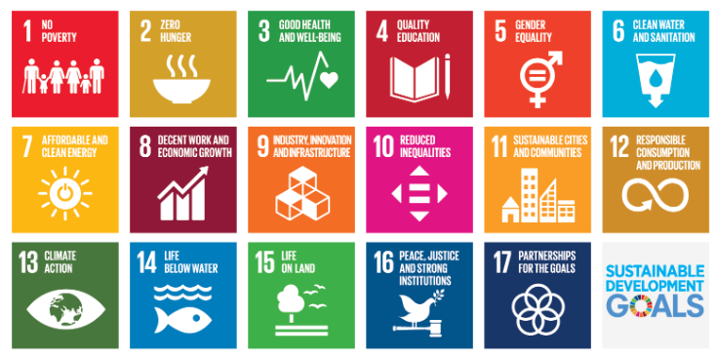
Fig 1.1 Sustainable development goals [1]

1.7 Objective of Project Report
This project report presents the comprehensive development and implementation of the AI-powered Chacha Chaudhary mascot system aimed at strengthening the river-people connection for the Namami Gange initiative. The report begins by outlining the motivation and background, highlighting the ecological and cultural importance of the River Ganga and the pressing need to enhance public awareness and engagement through innovative technological means.
The document then details the specific objectives, measurable outcomes, and challenges addressed by the project. It elaborates on the proposed methodology incorporating cutting-edge AI and Machine Learning technologies, including advanced Natural Language Processing (NLP) frameworks such as PyTorch, TensorFlow, NLTK, spaCy, and Transformers, emphasizing multilingual support for Hindi, English, and Bengali.
Further sections cover the functional software unit design, system architecture, and process flows demonstrating the integration of user interaction components, AI/ML processing layers, knowledge repositories, and cloud infrastructure. Detailed design documents, development strategies, and testing plans are described to ensure robustness and scalability.
The report concludes with discussions on feasibility, resource requirements, cost analysis, and future enhancement possibilities, providing a holistic view of how technology and culture blend to create an engaging, impactful tool for environmental conservation and community education.
This overview serves as a roadmap for understanding the scope, technical depth, and societal value embedded in the Chacha Chaudhary AI system deployment for Namami Gange conservation efforts.

Chapter 2
Literature review
- Social Robots in Education: Belpaeme et al. (2018) show robots improve student engagement.
- Human-Robot Interaction: Lee (2010) highlights how people adapt communication styles when engaging with robots.
- Chatbots in Environmental Campaigns: Arizona Water Chatbot (2024) successfully guided citizens in sustainable water use.
- Limitations of Past Approaches:
  - Rule-based chatbots = rigid, poor at handling diverse queries.
  - Template systems = lack personalization.
  - Lack of multilingual support restricted impact in India’s diverse linguistic context.
  - Limited real-time data integration prevented dynamic, situation-aware responses.
- Gap Identified: No existing chatbot integrates Indian cultural elements with advanced AI/ML for environmental conservation.Social Robots in Education: Belpaeme et al. (2018) demonstrated that robots enhance student engagement.

Human-Robot Interaction: Lee (2010) underscored the adaptive nature of human communication styles when interacting with robots.

Chatbots in Environmental Campaigns: The Arizona Water Chatbot (2024) successfully guided citizens in promoting sustainable water use.

Limitations of Previous Approaches:
- Rule-based chatbots exhibited rigidity and were ineffective in addressing diverse inquiries.
- Template systems lacked the capacity for personalization.
- The absence of multilingual support significantly restricted their impact within India's linguistically diverse context.
- Limited real-time data integration impeded the provision of dynamic, situation-aware responses.
Identified Gap: A notable absence exists in current solutions regarding a chatbot that seamlessly integrates Indian cultural elements with advanced AI/ML technologies for environmental conservation.

Summary of Literatures reviewed
Table 2.1 Summary of Literature reviews
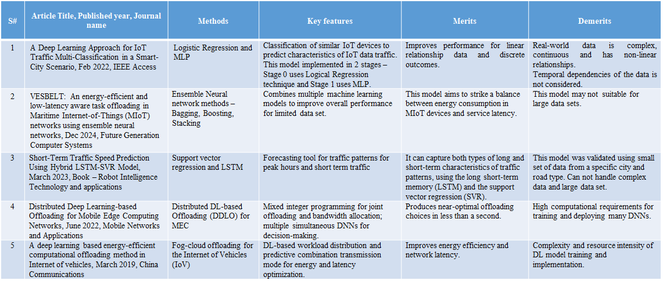

Chapter 3
Methodology

Requirement Analysis
- Identify target users (students, communities, museum visitors), their specific needs, and preferred languages.
System Architecture
- User Interaction Module: Facilitate interaction through voice, text, and gesture.
- Speech/Text Processing: Incorporate Automatic Speech Recognition (ASR), Text-to-Speech (TTS), and multilingual input capabilities.
- NLP & Dialogue Manager: Implement intent recognition, sentiment analysis, and personalized response generation.
- Knowledge Repository: Establish a comprehensive repository containing facts, comics, videos, and conservation tips.
- Cloud Infrastructure: Utilize cloud platforms such as AWS EC2 GPUs, SageMaker, and GCP Dialogflow.
AI/ML Models
- Employ Transformer-based models (e.g., BERT, GPT variants), fine-tuned for various Indian languages.
- Leverage transfer learning to optimize training costs and enhance operational efficiency.
Tools
- ML Development: PyTorch/TensorFlow.
- NLP: HuggingFace Transformers.
- Digital Avatar: Unity/Blender.
- Structured Data Storage: PostgreSQL.
Testing Plan
- Conduct unit testing, integration testing, and pilot deployment in Ganga museums.
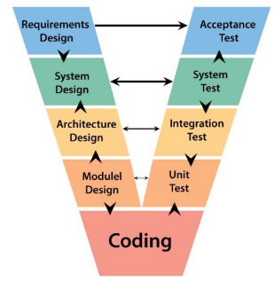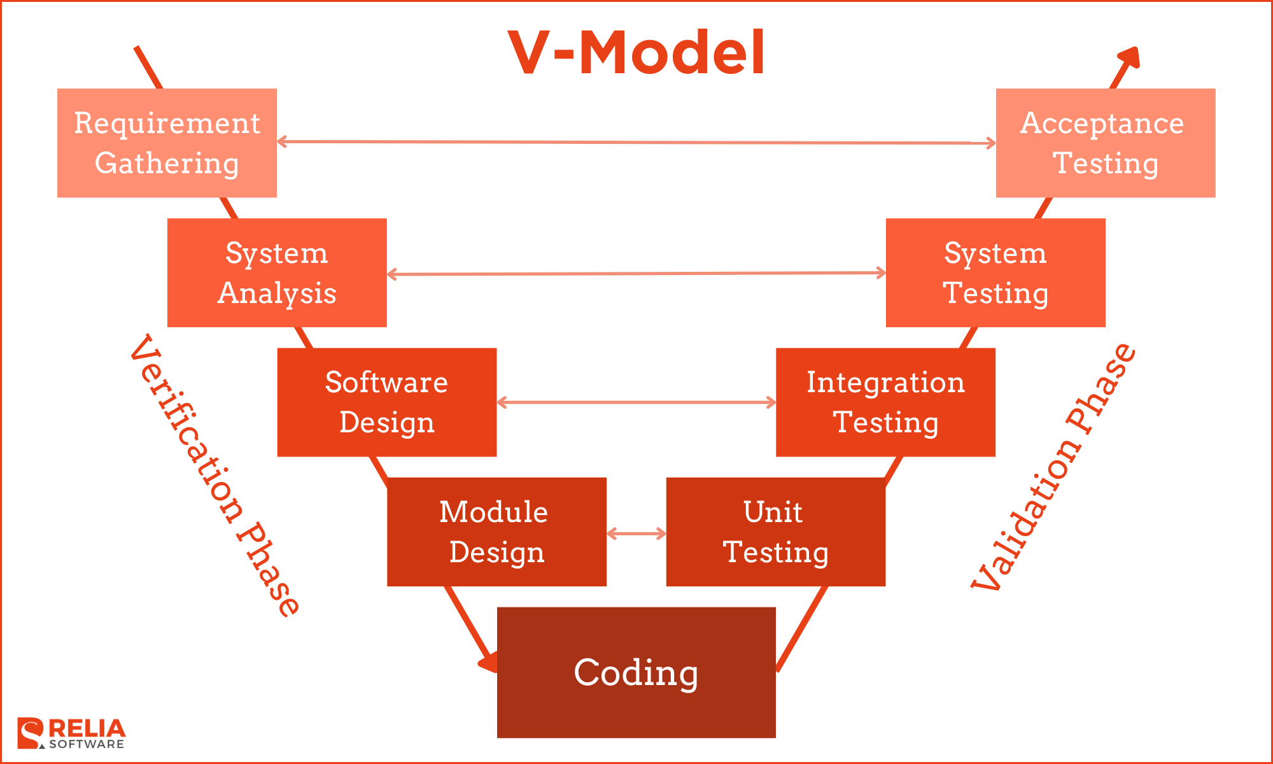
Fig 3.1 The V model methodology [4]
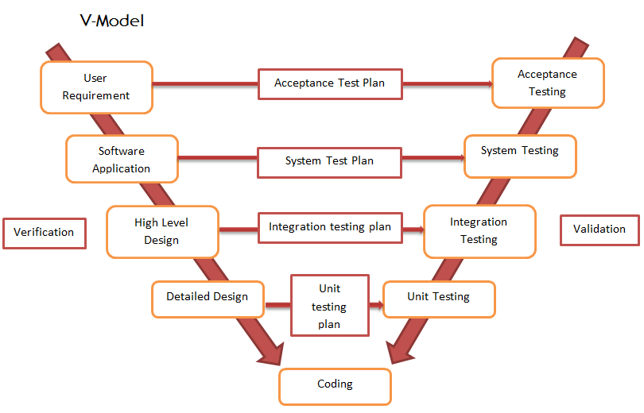
Fig 3.2 Another example of the V model methodology [5]

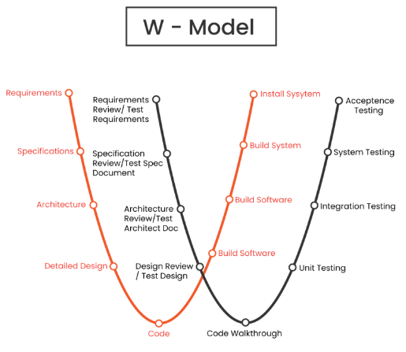
Fig 3.3 The W model methodology [6]
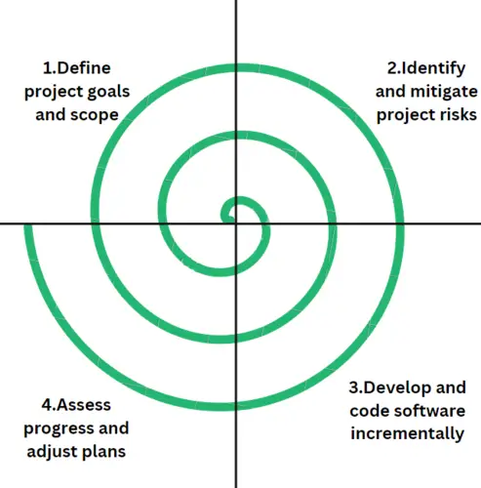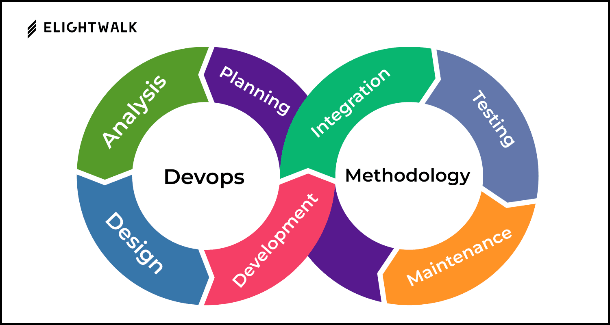
Fig 3.4 The Devops methodology [7]
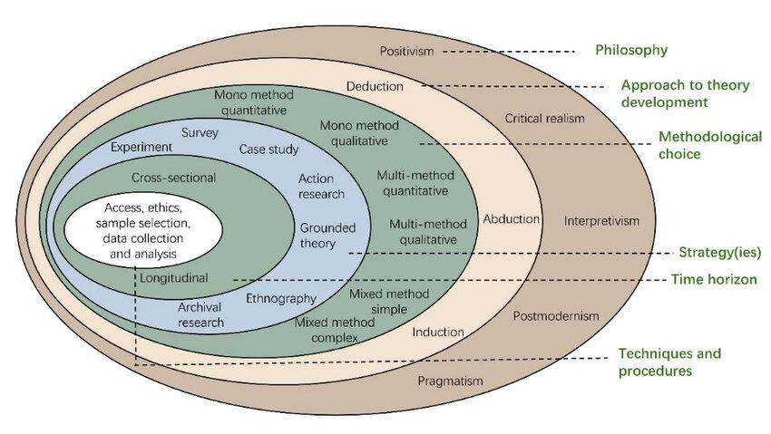
(a)
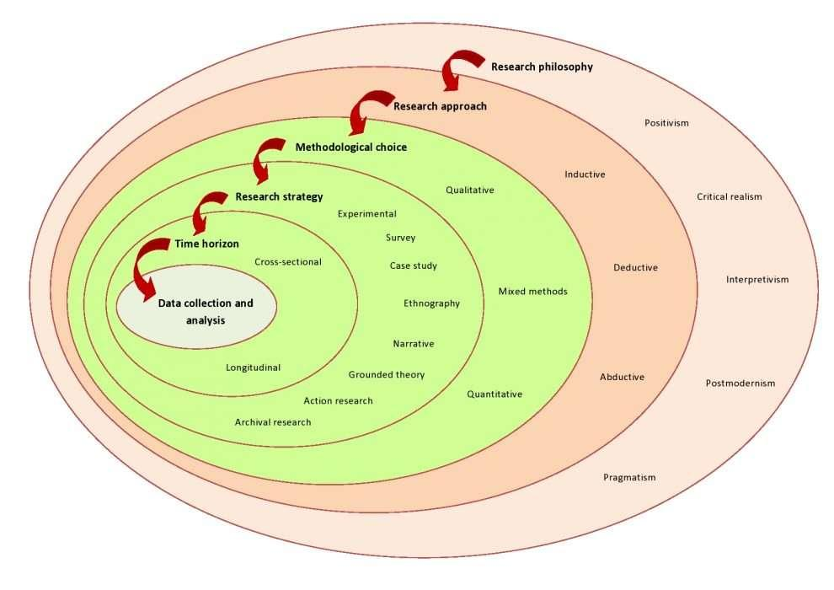
(b)
Fig 3.5 (a) Onion methodology, (b) another example [8]
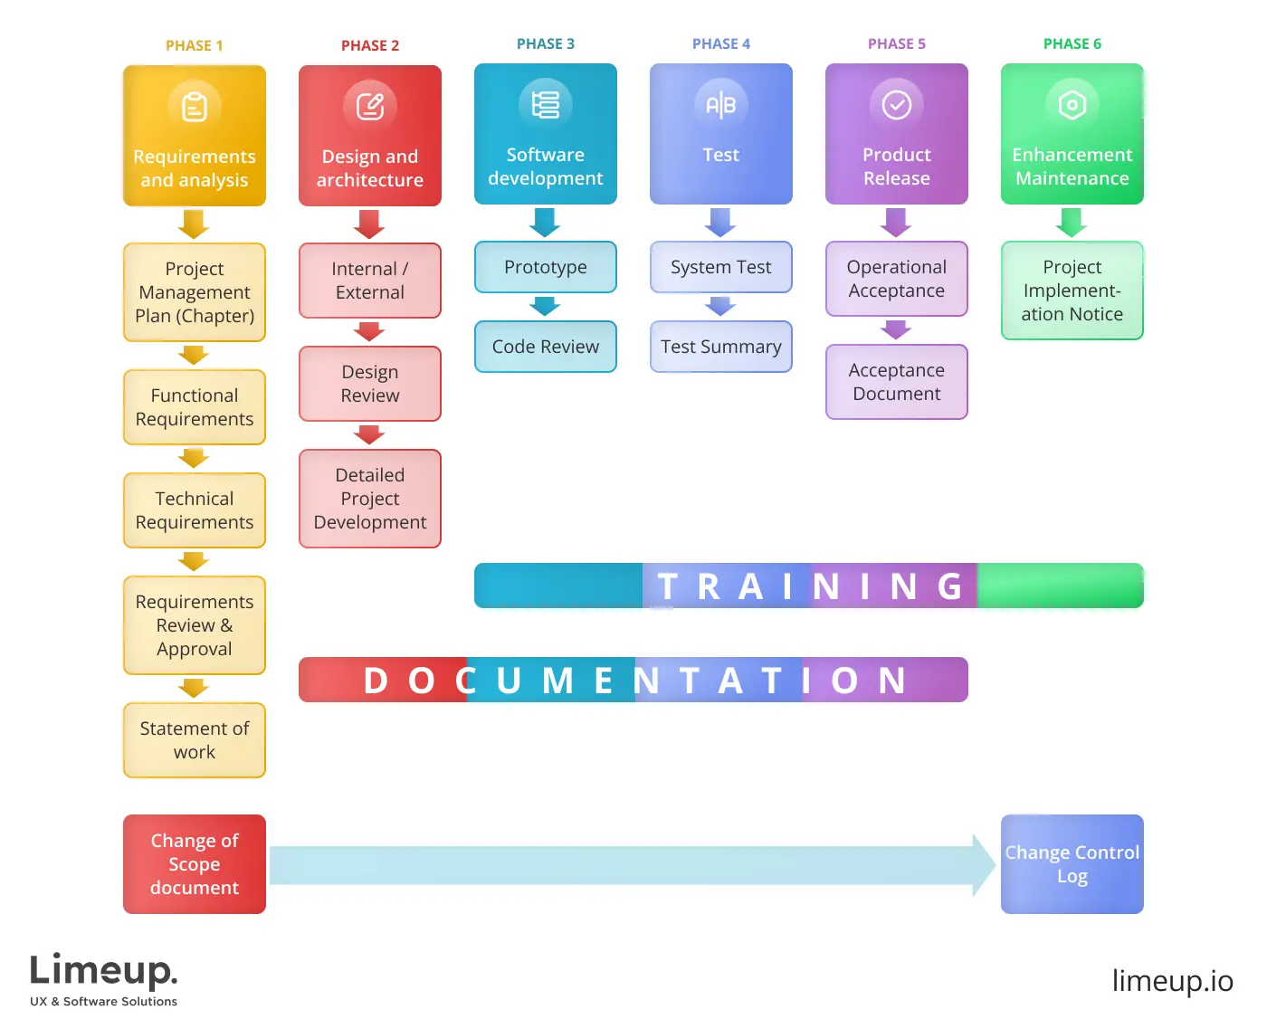
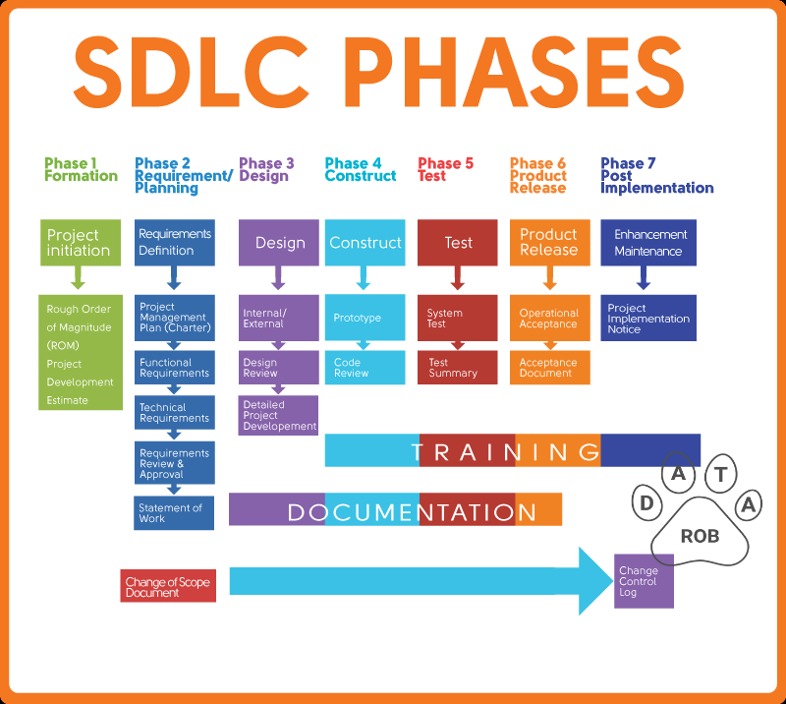
Fig 3.6 SDLC phases [9]
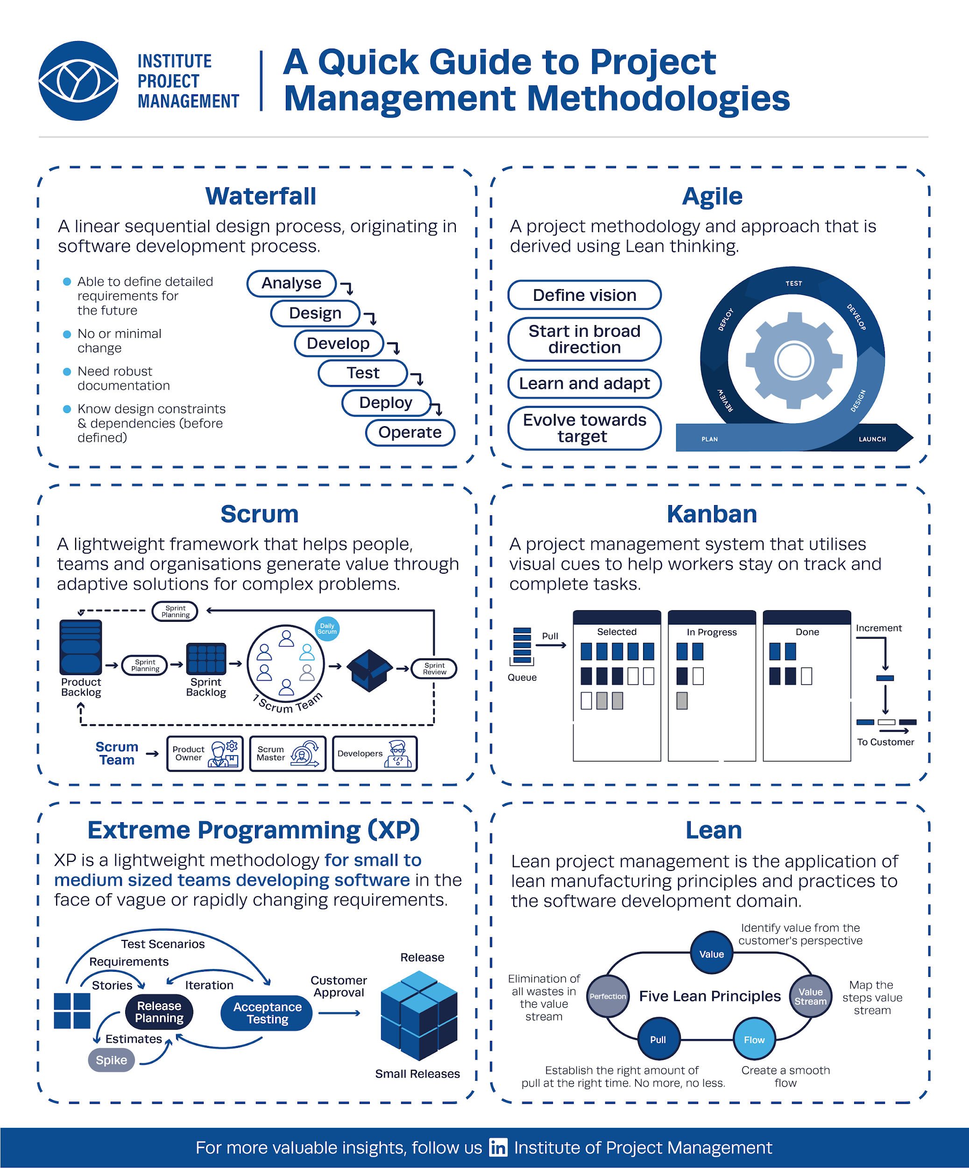
Fig 3.7 Summary of various methodology [10]
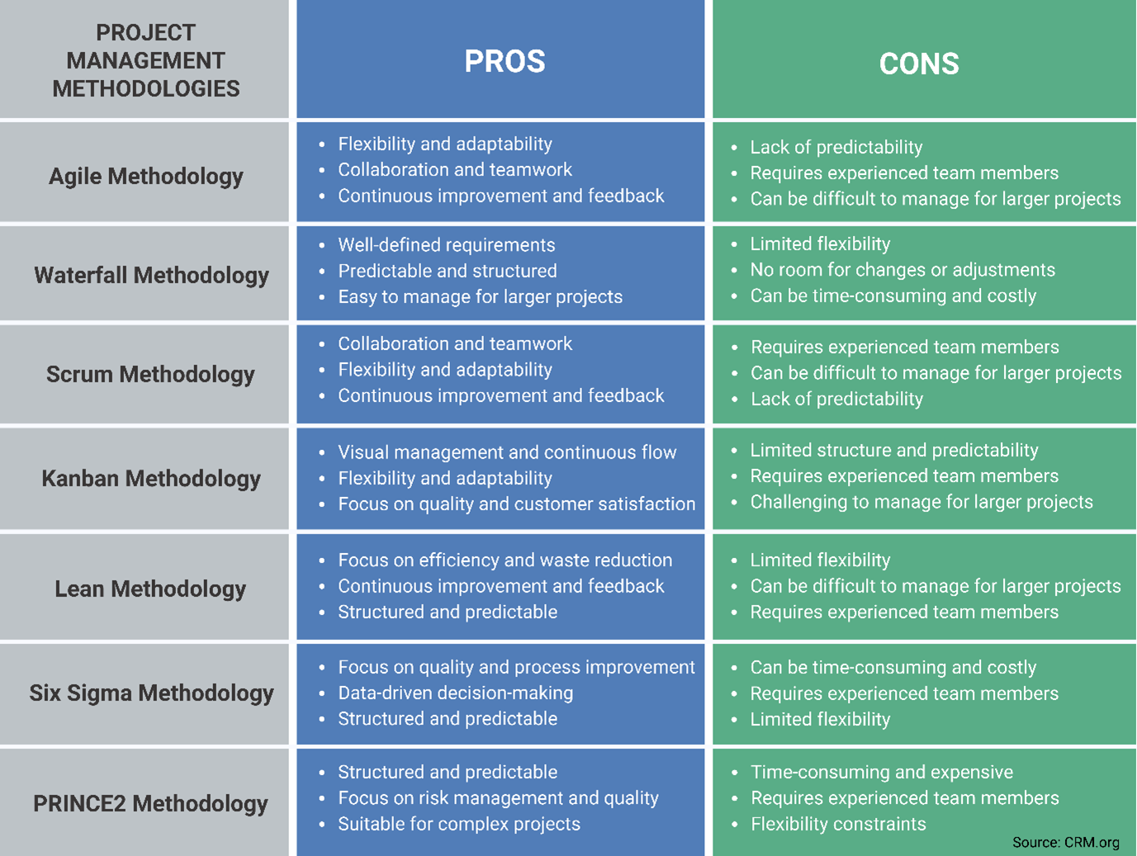
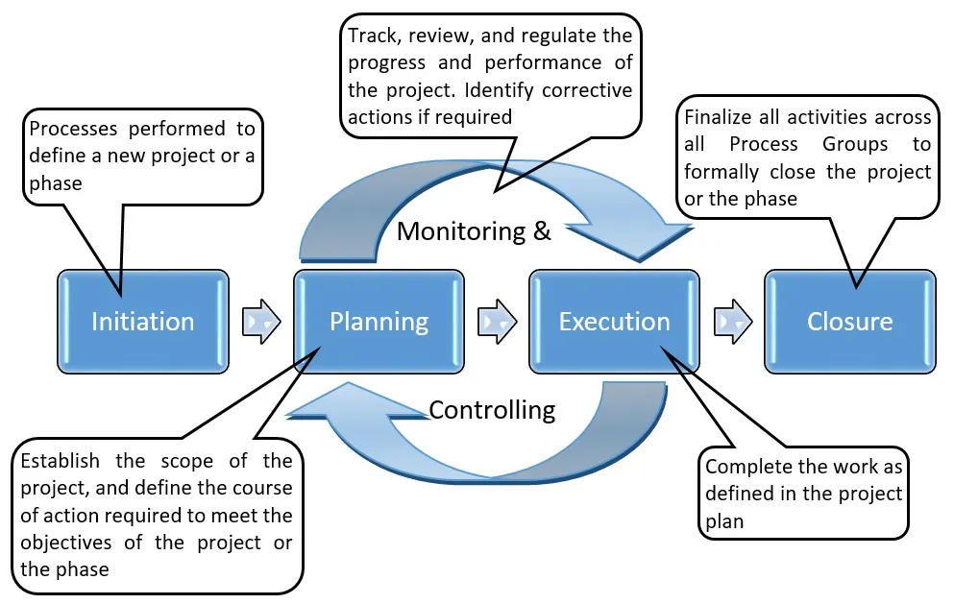

Fig 3.8 Some more methodologies [11]

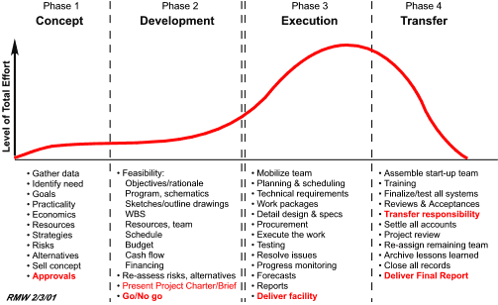
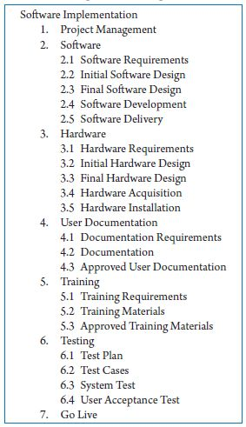
Fig 3.9 Summary of project breakdown to task [12]
Chapter 4
Project Management
4.1 Project timeline
Table 4.1 Project planning timeline
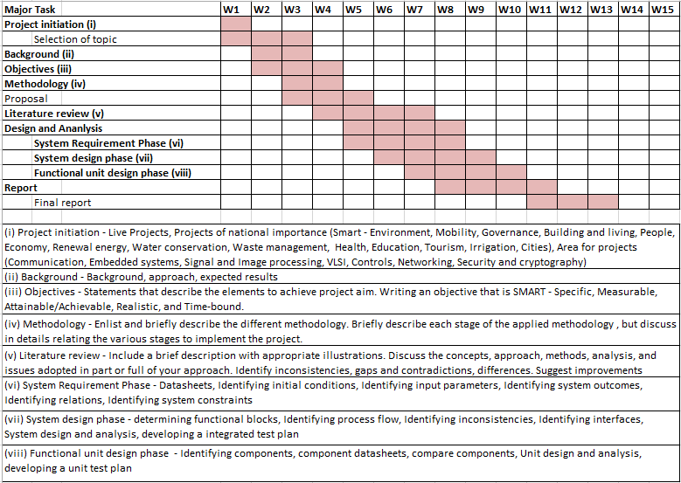

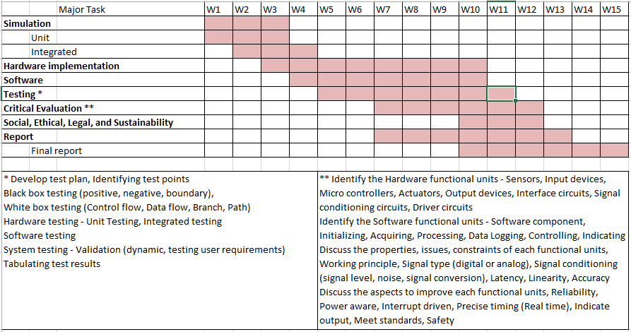

4.2 Risk analysis

PESTLE Analysis

Political
- Government Support: The Namami Gange initiative is government-backed, providing strong policy support and funding, which positively impacts project approval and resources.
- Regulatory Compliance: Adherence to data privacy laws and AI regulations is mandatory to avoid legal risks.
- Stakeholder Alignment: Coordination between multiple government agencies and local bodies is required for smooth deployment.

Economic
- Funding Availability: Reliance on allocated government budgets and grants necessitates efficient cost management to avoid overruns.
- Cost of Technology: Cloud services, AI infrastructure, and development resources need careful budgeting to balance cost and scalability.
- Economic Impact: The project could stimulate local economies by creating awareness and employment opportunities in river conservation.

Social
- Cultural Resonance: Leveraging the popular mascot Chacha Chaudhary enhances acceptance and engagement across diverse demographic groups.
- Public Awareness: Success depends on changing traditional behaviors and increasing environmental consciousness.
- Digital Divide: Addressing literacy and internet access disparities is crucial for inclusivity.

Technological
- AI and NLP Advances: Rapid innovations in AI models can enhance chatbot intelligence and user experience but require continuous updates.
- Integration Challenges: Seamless integration with cloud services, sensors, and multiple platforms is complex.
- Data Security: Protecting user and environmental data from breaches or misuse is critical.

Legal
- Privacy Laws: Compliance with data protection regulations such as GDPR or India’s data privacy framework is essential.
- Intellectual Property: Safeguarding copyrights, especially regarding the Chacha Chaudhary character usage.
- Ethical AI Use: Ensuring transparency and fairness in AI-driven interactions to avoid bias.

Environmental
- Sustainability Goals: Reinforces environmental protection efforts aligned with river conservation.
- Resource Constraints: Hardware and energy consumption of AI processing need sustainable sourcing and management.
- Local Ecological Impact: Effective community engagement can mitigate pollution and improve biodiversity.

Table 4.3 PESTEL analysis [13]
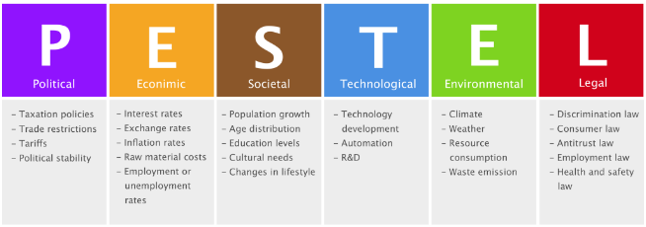

Table 4.5 Project phase risk matrix [15]
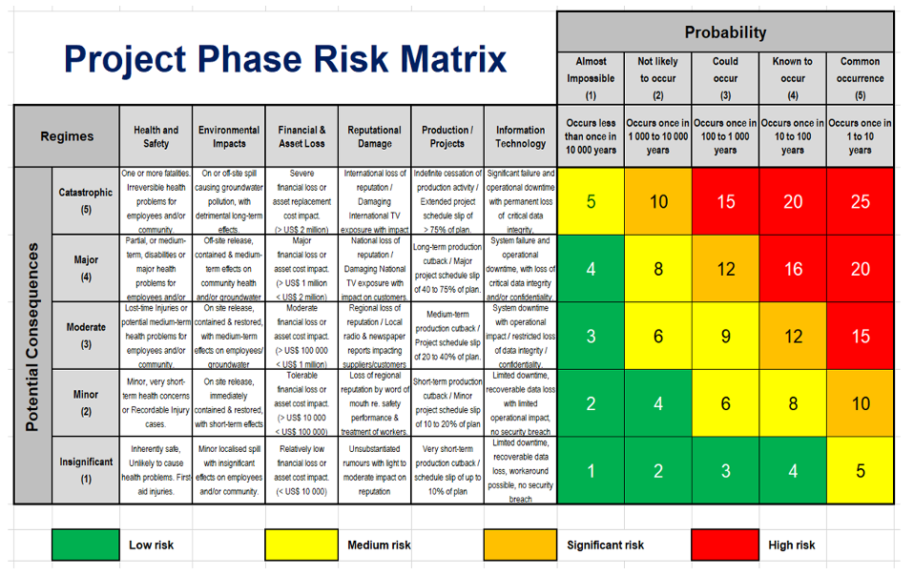

4.3 Project budget

Step 1: List All Tasks and Resource Requirements
- Requirement Gathering (Project Manager, Business Analyst)
- System Architecture Design (System Architect, AI Specialist)
- AI/ML Model Development (Data Scientists, NLP Experts)
- Chatbot and Avatar UI Development (Frontend Developers, UI/UX Designers)
- Backend Development and Integration (Backend Developers, DevOps)
- Testing and Validation (QA Engineers, Testers)
- Deployment and Monitoring (DevOps, Support Staff)
- Marketing and Community Engagement (Outreach Coordinator)

Step 2: Check Team Availability
- Assess current availability of internal staff, external consultants, and partners
- Align timelines with resource capacity and address any recruitment needs

Step 3: Estimate Task Duration
- Requirement Gathering: 2 weeks
- Design Phase: 2 weeks
- Model Development: 4 weeks
- Software Development: 6 weeks
- Testing: 4 weeks
- Deployment: 2 weeks
- Community Activities: ongoing throughout project

Step 4: Use Your Experience and Data
- Leverage prior projects for realistic estimations
- Adjust for project-specific complexity and multilingual requirements

Step 5: Set the Project Budget
- Include personnel costs, cloud infrastructure, licenses, hardware, marketing, and contingency
- Example budget categories and estimated costs are captured in Table 4.6

Step 6: Keep Track of Project Budget and Assess the Team
- Use budgeting tools and regular progress reviews to monitor spending
- Assess team performance and adjust resources or scope as needed

Table 4.6 Project budget [16]

Category | Description | Estimated Cost (₹ INR) | Notes
Personnel | Part-time volunteer support | ₹1,200 | Limited hours, AI/Dev contributions
Cloud Infrastructure | Minimal cloud/free tier usage | ₹800 | Basic API calls, model hosting
Software Licenses | Open-source tools and libraries | ₹0 | Using free NLP libraries, open source
Hardware | Basic demonstration setup | ₹1,000 | Low-cost single kiosk or workstation
Marketing & Outreach | Social media & grassroots | ₹700 | Volunteer-driven promotion
Contingency | Small buffer | ₹300 | Covers incidental expenses
Total |  | ₹5000

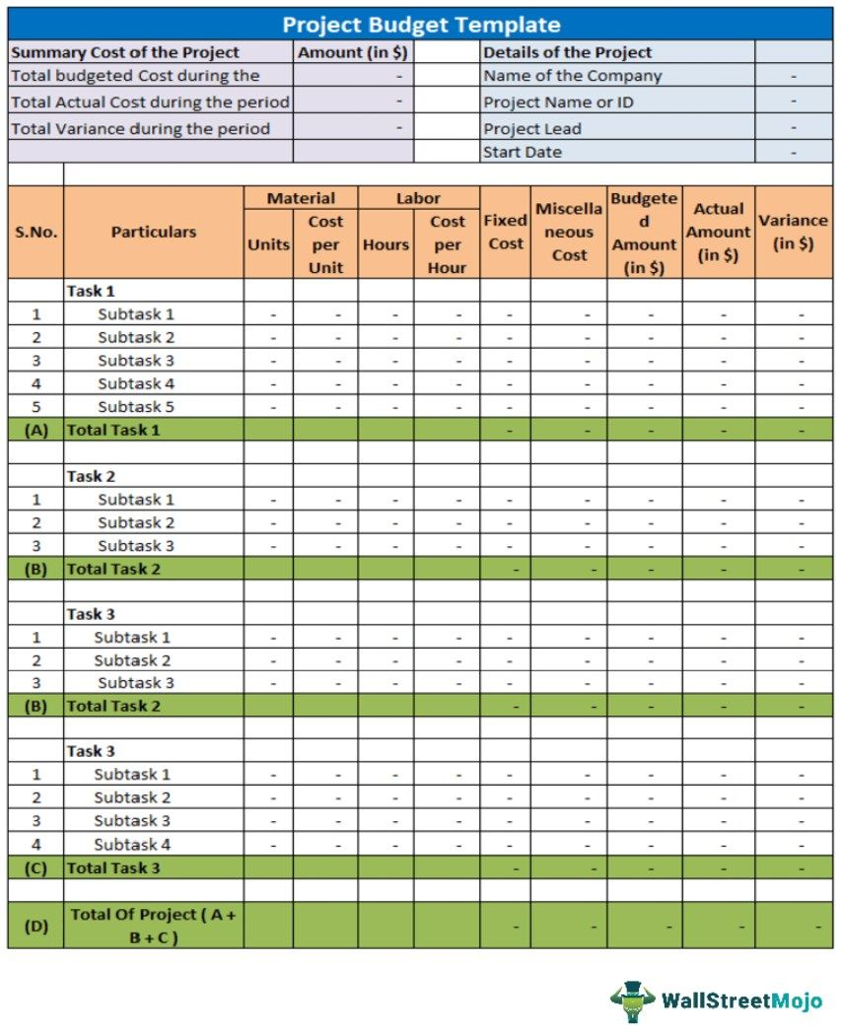

Chapter 5
Analysis and Design

5.1 Requirements
Software Requirements:
- Deep Learning: PyTorch 2.0+, TensorFlow 2.x.
- NLP Libraries: NLTK, spaCy, HuggingFace.
- Database: PostgreSQL 15+ with JSON support.
- Cloud: AWS (GPU instances, Lambda, CloudFront), GCP (Vertex AI, BigQuery).
Key Challenges:
- Handling multilingual speech recognition in noisy outdoor settings.
- Maintaining conversational context over long sessions.
- Avoiding biases in AI responses.

Requirement Aspect | Description
Purpose | An AI-powered interactive mascot system to educate and engage communities in river conservation under the Namami Gange program.
Behaviour | Supports multi-lingual chatbot conversations, real-time response generation, and context-aware dialogue management.
System Management | Provides remote monitoring, real-time analytics dashboard, and update capabilities for AI models and content.
Data Analysis | Performs live NLP processing, sentiment analysis, entity recognition, and personalized interaction logging.
Application Deployment | Deploys on cloud infrastructure with web and kiosk interfaces; accessible across devices and low-bandwidth conditions.
Security | Incorporates user authentication and data encryption to protect user privacy and system integrity.

System SW design phase

- Functional blocks: Multilingual ASR, text normalization and language detection, PII/profanity redaction, NLU (intent/entity), dialogue manager/policies with memory store, tool/action orchestrator, knowledge connectors, TTS with visemes, avatar renderer, and telemetry.rasa+1
- Process flow: User utterances traverse preprocessing to NLU and dialogue policies, which query knowledge/tools, then generate text plus TTS with viseme events for synchronized avatar playback.rasa+1
- Identify inconsistencies: Detect misrouted languages, insufficient entity coverage, policy loops, safety/guardrail gaps, and desync between TTS audio and avatar visemes.techcommunity.microsoft+1
- Design interfaces: Rasa action server endpoints for tool calls, channel/webhook adapters for messaging, REST/gRPC for knowledge APIs, and TTS viseme event streams consumed by the avatar engine.rasa+1
- System design and analysis: Employ microservice decomposition for NLU, dialogue, action server, and content services, with enterprise workflow tooling to manage versioning, review, and safe rollouts.rasa+1
- Integrated test plan (SW): Map unit, integration, system, and acceptance tests to the V-model, validating intents/entities, ASR→NLU integration, end-to-end dialogues with avatar sync, and stakeholder acceptance on target journeys.browserstack+1

Integrated V-model test mapping
- Requirements ↔ Acceptance testing: Validate river–people engagement journeys, accessibility, and persona consistency with real users and stakeholders.browserstack+1
- System design ↔ System testing: Verify end-to-end conversational flows, safety guardrails, performance and resilience under load across channels and kiosks.visuresolutions+1
- Architecture/HLD ↔ Integration testing: Test ASR→NLU→dialogue→TTS/viseme→avatar pipeline, including API contracts and timing across services and hardware.code-intelligence+1
- TTS/viseme event parsing.rasa+1
- Specialized avatar tests: Use viseme timelines from Azure or similar to assert lip-sync alignment, mouth shapes, and timing fidelity under varied content and speeds.aws.amazon+1

HW/SW interface definitions
- Audio interface: 16 kHz or 24 kHz PCM from capture to ASR, with WebRTC AEC/NS where applicable; output audio from TTS in standard codecs for playback.techcommunity.microsoft+1
- Avatar interface: Viseme event stream with IDs and timestamps consumed by the avatar renderer for synchronized mouth shapes and expressions.aws.amazon+1
- Conversational interfaces: Rasa NLU/dialogue over defined APIs with an action server for tool execution and knowledge retrieval.rasa+1
- Channel adapters: Webhooks/connectors for mobile/web/kiosk channels to transport text, audio, and avatar video frames or streams.rasa+1

Inconsistency detection and resolution
- Modal mismatch: Language detection vs. model selection drift; mitigate by routing policies and multilingual pipelines.visuresolutions+1
- Timing drift: TTS audio vs. viseme playback lag; apply buffered playback and timestamp alignment from viseme events.aws.amazon+1
- Policy conflicts: Dialogue loops or dead-ends; resolve via policy tests and story evaluations in CI before promotion.rasa+1

Test plan outline (integrated)
- Strategy and scope: Define objectives, entry/exit criteria, test environments (edge kiosks, staging cloud), and risk-based prioritization aligned to the V-model.browserstack+1
- Test levels and cases: Unit, integration, system, and acceptance suites with traceability back to requirements and design artifacts.tutorialspoint+1
- Data and oracles: Curate multilingual utterances, river-domain FAQs, and scripted dialogues; establish pass/fail oracles for intents, entities, and avatar sync thresholds.rasa+1
- Environments and tooling: HIL-style rigs for AV timing, automation for NLU/dialogue regression, and scripted runs for viseme-lip sync validation.code-intelligence+1
- Governance and rollout: Defect triage, re-test, regression cycles, and gated promotions via enterprise workflow tooling and staged environments.rasa+1
Share
- ExportDetailed design ↔ Unit testing: Cover NLU intent/entity classifiers, dialogue policies, redaction filters, and
Rewrite

5.2 Block diagram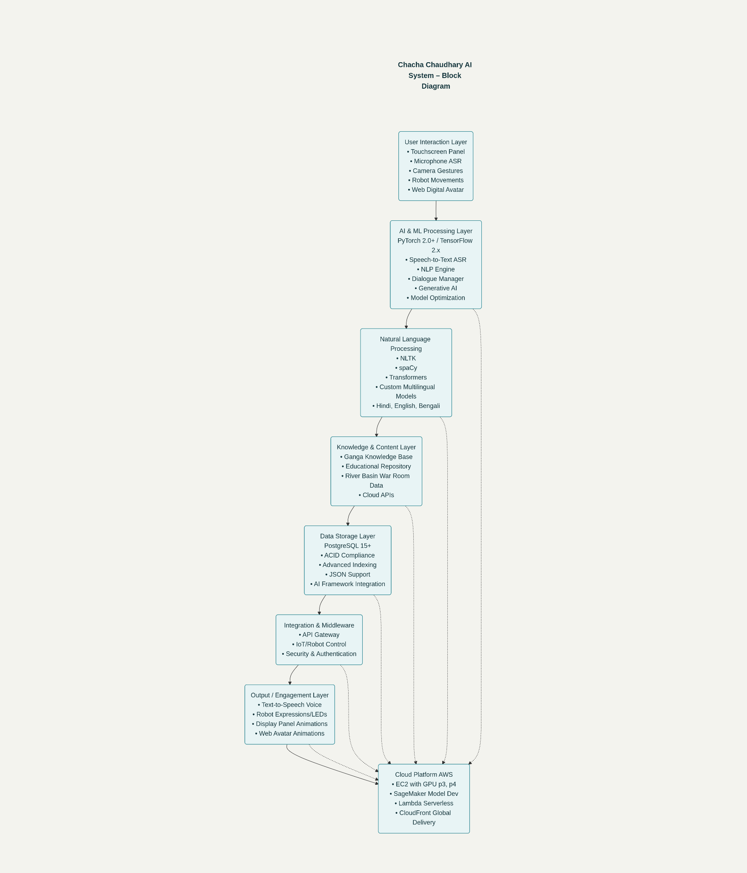

Fig 5.1 Functional block diagram

5.3 System Flow chart
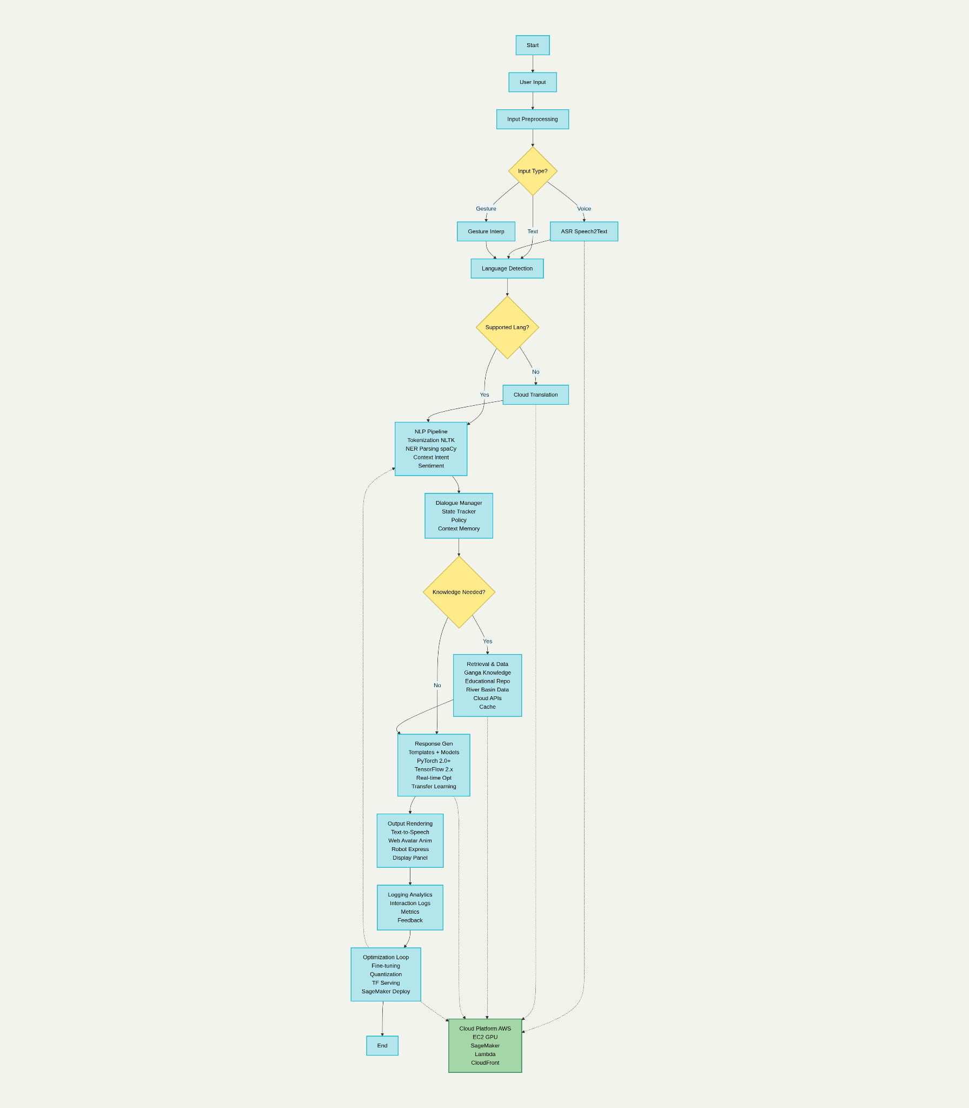
Fig 5.2 System flow chart
Functional SW unit design phase
The functional software unit design phase translates high-level architecture into detailed, implementable modules with precise interfaces, data structures, and algorithms for coding and unit testing readiness. It pairs each design activity with corresponding unit-level verification in SDLC models like the V-Model to ensure early test planning and traceability.baeldung+2
- Purpose: Convert HLD into low-level designs that specify class diagrams, algorithms, data schemas, interfaces, and error handling for each unit.baeldung
- Key activities: Produce LLD for modules, write functional specifications (inputs/outputs/rules/use cases), and define inter-module contracts and dependencies.walkingtree+1
- Deliverables: Low-Level Design artifacts (class/sequence/activity/state diagrams), Functional Design/Specification documents, and unit test plans linked to module design.geeksforgeeks+2
- Functional specification scope: Capture use cases, inputs/outputs, workflows, UI/report expectations, and regulatory conformance to guide build and test unambiguously.imperiumdynamics+1
- Testing alignment (V-Model): Prepare unit tests during module design and validate module code post-implementation, ensuring verification/validation alignment.bdtask+1
- Success criteria: All units have complete LLD and functional specs, interfaces are documented, and unit tests are ready to execute with clear acceptance criteria.techtarget+1

5.6 Standards
(Discuss and describe the various standards that are relevant and required for the project
- Ensure proper citation and referencing.
Standards are technical specifications that ensure interoperability, security, and data exchange between various devices and systems. They cover areas like communication protocols, data formats, security, and device management, allowing devices from different manufacturers to work together seamlessly.
Key aspects of IoT standards are Interoperability, Security, Data Formats and Protocols, Device Management.
- Communication Protocols: Standards like Wi-Fi, Bluetooth, ZigBee, MQTT, and CoAP.
- Data Formats: Standards like JSON, XML, and CBOR are used for exchanging data between devices and platforms.
- Security: Standards such as TLS for secure communication and standards related to data privacy and device security.
- Architecture and Interoperability: Standards related to layered architectures or specific device interactions.
Benefits of using IoT standards are
- Reduced Development Costs: Standards streamline development by providing a common framework and reducing the need for custom solutions.
- Improved Interoperability: Standards enable devices from different manufacturers to work together, creating a more flexible and dynamic IoT ecosystem.
- Enhanced Security: Standards provide guidance on security best practices, helping to mitigate risks and protect sensitive data.
- Increased Innovation: By providing a foundation for interoperability and security, standards enable innovation and the development of new IoT applications.
e.g.
IEEE develops standards for various aspects of IoT, including
Wireless communication (802.11, 802.15),
smart grids (1547), and
intelligent transportation (1609)

Key ISO standards for IoT devices include
Frameworks ISO/IEC 30141 (IoT Reference Architecture),
Secure design ISO/IEC 27400 and ISO/IEC 27402 (IoT Security & Privacy), and
Testing ISO/IEC 21823 series (Interoperability).

ITU: The ITU (International Telecommunication Union) focuses on establishing a global infrastructure for the IoT, ensuring interoperability and advanced services.
DDS (Data Distribution Service): A scalable IoT protocol for real-time and embedded systems, offering interoperable data exchange.
GS1: GS1 provides standards for identifying objects and capturing data, crucial for the IoT ecosystem.
Key ISO standards for IT include
ISO/IEC 27001 for information security management,
ISO 9001 for quality management, and
ISO 20000 for IT service management.

Other relevant standards helping organizations manage risks, improve efficiency, and ensure compliance in a complex IT landscape cover
business continuity (ISO 22301),
data privacy (ISO 27701), and
Artificial Intelligence management (ISO/IEC 42001)

communication standards – PCI, UART, I2C, SPI, CAN, etc. MQTT, CoAP, OPC UA: These are popular communication protocols used in IoT for different purposes.
Other standards like Power supply standards, interfacing standards, etc.)
5.7 Mapping with IoTWF reference model layers (in tabular form)
(The IoT World Forum offers a clean, simplified perspective on IoT and includes edge computing, data storage, and access.
• It provides a clear way of visualizing IoT from a technical perspective.
• Each of the seven layers is broken down into specific functions, and security encompasses the entire model.
Using this reference model, we are able to achieve the following:
1. Decompose the IoT problem into smaller parts
2. Identify different technologies at each layer and how they relate to one another
3. Define a system in which different parts can be provided by different vendors
4. Have a process of defining interfaces that leads to interoperability
5. Define a tiered security model that enforced at the transition points between levels)

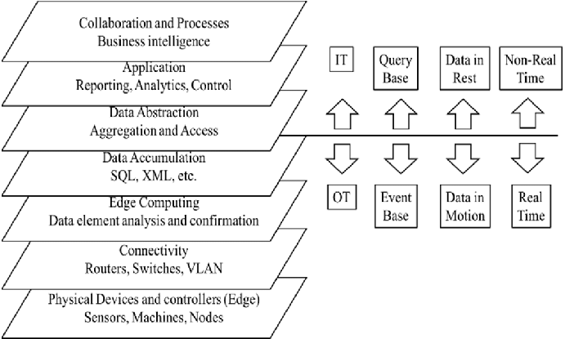

Fig 5.5 The IoT World Forum Reference Model

5.8 Domain model specification
(The domain model describes the main concepts, entities and objects in the domain of the IoT system to be designed.
- Domain model defines the attributes of the objects and relationships between objects.
- The domain model is independent of any specific technology or platform
- It consist of physical entities, virtual entities, devices, resources, services as defined in table below
Table 5.5 Description of Domain model
Physical Entity  - These are the real-world objects related to the project environment, such as the river ecosystem components, physical kiosks, cameras, microphones, and environmental sensors deployed along the River Ganga.  - The IoT system collects data like water quality, pollution levels, and visitor movement using sensors attached to these physical entities.  Virtual Entity  - The digital representation of each physical entity within the system.  - For example, the environmental data collected from sensors in the river is reflected as digital objects or metrics in the AI system's dashboards or chatbot knowledge base.  - The interactive 3D digital avatar of Chacha Chaudhary acts as a virtual entity, representing a persona in the digital world.  Device  - Devices serve as interfaces facilitating communication between the physical and virtual entities.  - This includes kiosks with touchscreen displays, microphones for speech input (ASR), cameras for gesture recognition, and servers or edge computing devices processing data.  - These devices enable sensing, processing, and actuating capabilities between the user and the environment.  Resource  - Resources are software components operational on devices or available over networks.  - On-device resources include embedded operating systems, sensor drivers, and local data processing algorithms.  - Network resources cover cloud databases storing river ecology data, AI models on cloud platforms, and APIs connecting various services.  Service  - Services provide functionalities to interact with physical entities by accessing these resources.  - For example, a service may retrieve real-time sensor data to inform the chatbot's responses or trigger a physical alert (e.g., LEDs on kiosks) to draw attention.  - They define the interfaces and protocols through which components communicate and perform their operations. | Physical Entity  - These are the real-world objects related to the project environment, such as the river ecosystem components, physical kiosks, cameras, microphones, and environmental sensors deployed along the River Ganga.  - The IoT system collects data like water quality, pollution levels, and visitor movement using sensors attached to these physical entities.  Virtual Entity  - The digital representation of each physical entity within the system.  - For example, the environmental data collected from sensors in the river is reflected as digital objects or metrics in the AI system's dashboards or chatbot knowledge base.  - The interactive 3D digital avatar of Chacha Chaudhary acts as a virtual entity, representing a persona in the digital world.  Device  - Devices serve as interfaces facilitating communication between the physical and virtual entities.  - This includes kiosks with touchscreen displays, microphones for speech input (ASR), cameras for gesture recognition, and servers or edge computing devices processing data.  - These devices enable sensing, processing, and actuating capabilities between the user and the environment.  Resource  - Resources are software components operational on devices or available over networks.  - On-device resources include embedded operating systems, sensor drivers, and local data processing algorithms.  - Network resources cover cloud databases storing river ecology data, AI models on cloud platforms, and APIs connecting various services.  Service  - Services provide functionalities to interact with physical entities by accessing these resources.  - For example, a service may retrieve real-time sensor data to inform the chatbot's responses or trigger a physical alert (e.g., LEDs on kiosks) to draw attention.  - They define the interfaces and protocols through which components communicate and perform their operations.
Physical Entity  - These are the real-world objects related to the project environment, such as the river ecosystem components, physical kiosks, cameras, microphones, and environmental sensors deployed along the River Ganga.  - The IoT system collects data like water quality, pollution levels, and visitor movement using sensors attached to these physical entities.  Virtual Entity  - The digital representation of each physical entity within the system.  - For example, the environmental data collected from sensors in the river is reflected as digital objects or metrics in the AI system's dashboards or chatbot knowledge base.  - The interactive 3D digital avatar of Chacha Chaudhary acts as a virtual entity, representing a persona in the digital world.  Device  - Devices serve as interfaces facilitating communication between the physical and virtual entities.  - This includes kiosks with touchscreen displays, microphones for speech input (ASR), cameras for gesture recognition, and servers or edge computing devices processing data.  - These devices enable sensing, processing, and actuating capabilities between the user and the environment.  Resource  - Resources are software components operational on devices or available over networks.  - On-device resources include embedded operating systems, sensor drivers, and local data processing algorithms.  - Network resources cover cloud databases storing river ecology data, AI models on cloud platforms, and APIs connecting various services.  Service  - Services provide functionalities to interact with physical entities by accessing these resources.  - For example, a service may retrieve real-time sensor data to inform the chatbot's responses or trigger a physical alert (e.g., LEDs on kiosks) to draw attention.  - They define the interfaces and protocols through which components communicate and perform their operations. | Physical Entity  - These are the real-world objects related to the project environment, such as the river ecosystem components, physical kiosks, cameras, microphones, and environmental sensors deployed along the River Ganga.  - The IoT system collects data like water quality, pollution levels, and visitor movement using sensors attached to these physical entities.  Virtual Entity  - The digital representation of each physical entity within the system.  - For example, the environmental data collected from sensors in the river is reflected as digital objects or metrics in the AI system's dashboards or chatbot knowledge base.  - The interactive 3D digital avatar of Chacha Chaudhary acts as a virtual entity, representing a persona in the digital world.  Device  - Devices serve as interfaces facilitating communication between the physical and virtual entities.  - This includes kiosks with touchscreen displays, microphones for speech input (ASR), cameras for gesture recognition, and servers or edge computing devices processing data.  - These devices enable sensing, processing, and actuating capabilities between the user and the environment.  Resource  - Resources are software components operational on devices or available over networks.  - On-device resources include embedded operating systems, sensor drivers, and local data processing algorithms.  - Network resources cover cloud databases storing river ecology data, AI models on cloud platforms, and APIs connecting various services.  Service  - Services provide functionalities to interact with physical entities by accessing these resources.  - For example, a service may retrieve real-time sensor data to inform the chatbot's responses or trigger a physical alert (e.g., LEDs on kiosks) to draw attention.  - They define the interfaces and protocols through which components communicate and perform their operations.
Physical Entity  - These are the real-world objects related to the project environment, such as the river ecosystem components, physical kiosks, cameras, microphones, and environmental sensors deployed along the River Ganga.  - The IoT system collects data like water quality, pollution levels, and visitor movement using sensors attached to these physical entities.  Virtual Entity  - The digital representation of each physical entity within the system.  - For example, the environmental data collected from sensors in the river is reflected as digital objects or metrics in the AI system's dashboards or chatbot knowledge base.  - The interactive 3D digital avatar of Chacha Chaudhary acts as a virtual entity, representing a persona in the digital world.  Device  - Devices serve as interfaces facilitating communication between the physical and virtual entities.  - This includes kiosks with touchscreen displays, microphones for speech input (ASR), cameras for gesture recognition, and servers or edge computing devices processing data.  - These devices enable sensing, processing, and actuating capabilities between the user and the environment.  Resource  - Resources are software components operational on devices or available over networks.  - On-device resources include embedded operating systems, sensor drivers, and local data processing algorithms.  - Network resources cover cloud databases storing river ecology data, AI models on cloud platforms, and APIs connecting various services.  Service  - Services provide functionalities to interact with physical entities by accessing these resources.  - For example, a service may retrieve real-time sensor data to inform the chatbot's responses or trigger a physical alert (e.g., LEDs on kiosks) to draw attention.  - They define the interfaces and protocols through which components communicate and perform their operations. | Physical Entity  - These are the real-world objects related to the project environment, such as the river ecosystem components, physical kiosks, cameras, microphones, and environmental sensors deployed along the River Ganga.  - The IoT system collects data like water quality, pollution levels, and visitor movement using sensors attached to these physical entities.  Virtual Entity  - The digital representation of each physical entity within the system.  - For example, the environmental data collected from sensors in the river is reflected as digital objects or metrics in the AI system's dashboards or chatbot knowledge base.  - The interactive 3D digital avatar of Chacha Chaudhary acts as a virtual entity, representing a persona in the digital world.  Device  - Devices serve as interfaces facilitating communication between the physical and virtual entities.  - This includes kiosks with touchscreen displays, microphones for speech input (ASR), cameras for gesture recognition, and servers or edge computing devices processing data.  - These devices enable sensing, processing, and actuating capabilities between the user and the environment.  Resource  - Resources are software components operational on devices or available over networks.  - On-device resources include embedded operating systems, sensor drivers, and local data processing algorithms.  - Network resources cover cloud databases storing river ecology data, AI models on cloud platforms, and APIs connecting various services.  Service  - Services provide functionalities to interact with physical entities by accessing these resources.  - For example, a service may retrieve real-time sensor data to inform the chatbot's responses or trigger a physical alert (e.g., LEDs on kiosks) to draw attention.  - They define the interfaces and protocols through which components communicate and perform their operations.
Physical Entity  - These are the real-world objects related to the project environment, such as the river ecosystem components, physical kiosks, cameras, microphones, and environmental sensors deployed along the River Ganga.  - The IoT system collects data like water quality, pollution levels, and visitor movement using sensors attached to these physical entities.  Virtual Entity  - The digital representation of each physical entity within the system.  - For example, the environmental data collected from sensors in the river is reflected as digital objects or metrics in the AI system's dashboards or chatbot knowledge base.  - The interactive 3D digital avatar of Chacha Chaudhary acts as a virtual entity, representing a persona in the digital world.  Device  - Devices serve as interfaces facilitating communication between the physical and virtual entities.  - This includes kiosks with touchscreen displays, microphones for speech input (ASR), cameras for gesture recognition, and servers or edge computing devices processing data.  - These devices enable sensing, processing, and actuating capabilities between the user and the environment.  Resource  - Resources are software components operational on devices or available over networks.  - On-device resources include embedded operating systems, sensor drivers, and local data processing algorithms.  - Network resources cover cloud databases storing river ecology data, AI models on cloud platforms, and APIs connecting various services.  Service  - Services provide functionalities to interact with physical entities by accessing these resources.  - For example, a service may retrieve real-time sensor data to inform the chatbot's responses or trigger a physical alert (e.g., LEDs on kiosks) to draw attention.  - They define the interfaces and protocols through which components communicate and perform their operations. | Physical Entity  - These are the real-world objects related to the project environment, such as the river ecosystem components, physical kiosks, cameras, microphones, and environmental sensors deployed along the River Ganga.  - The IoT system collects data like water quality, pollution levels, and visitor movement using sensors attached to these physical entities.  Virtual Entity  - The digital representation of each physical entity within the system.  - For example, the environmental data collected from sensors in the river is reflected as digital objects or metrics in the AI system's dashboards or chatbot knowledge base.  - The interactive 3D digital avatar of Chacha Chaudhary acts as a virtual entity, representing a persona in the digital world.  Device  - Devices serve as interfaces facilitating communication between the physical and virtual entities.  - This includes kiosks with touchscreen displays, microphones for speech input (ASR), cameras for gesture recognition, and servers or edge computing devices processing data.  - These devices enable sensing, processing, and actuating capabilities between the user and the environment.  Resource  - Resources are software components operational on devices or available over networks.  - On-device resources include embedded operating systems, sensor drivers, and local data processing algorithms.  - Network resources cover cloud databases storing river ecology data, AI models on cloud platforms, and APIs connecting various services.  Service  - Services provide functionalities to interact with physical entities by accessing these resources.  - For example, a service may retrieve real-time sensor data to inform the chatbot's responses or trigger a physical alert (e.g., LEDs on kiosks) to draw attention.  - They define the interfaces and protocols through which components communicate and perform their operations.
Physical Entity  - These are the real-world objects related to the project environment, such as the river ecosystem components, physical kiosks, cameras, microphones, and environmental sensors deployed along the River Ganga.  - The IoT system collects data like water quality, pollution levels, and visitor movement using sensors attached to these physical entities.  Virtual Entity  - The digital representation of each physical entity within the system.  - For example, the environmental data collected from sensors in the river is reflected as digital objects or metrics in the AI system's dashboards or chatbot knowledge base.  - The interactive 3D digital avatar of Chacha Chaudhary acts as a virtual entity, representing a persona in the digital world.  Device  - Devices serve as interfaces facilitating communication between the physical and virtual entities.  - This includes kiosks with touchscreen displays, microphones for speech input (ASR), cameras for gesture recognition, and servers or edge computing devices processing data.  - These devices enable sensing, processing, and actuating capabilities between the user and the environment.  Resource  - Resources are software components operational on devices or available over networks.  - On-device resources include embedded operating systems, sensor drivers, and local data processing algorithms.  - Network resources cover cloud databases storing river ecology data, AI models on cloud platforms, and APIs connecting various services.  Service  - Services provide functionalities to interact with physical entities by accessing these resources.  - For example, a service may retrieve real-time sensor data to inform the chatbot's responses or trigger a physical alert (e.g., LEDs on kiosks) to draw attention.  - They define the interfaces and protocols through which components communicate and perform their operations. | Physical Entity  - These are the real-world objects related to the project environment, such as the river ecosystem components, physical kiosks, cameras, microphones, and environmental sensors deployed along the River Ganga.  - The IoT system collects data like water quality, pollution levels, and visitor movement using sensors attached to these physical entities.  Virtual Entity  - The digital representation of each physical entity within the system.  - For example, the environmental data collected from sensors in the river is reflected as digital objects or metrics in the AI system's dashboards or chatbot knowledge base.  - The interactive 3D digital avatar of Chacha Chaudhary acts as a virtual entity, representing a persona in the digital world.  Device  - Devices serve as interfaces facilitating communication between the physical and virtual entities.  - This includes kiosks with touchscreen displays, microphones for speech input (ASR), cameras for gesture recognition, and servers or edge computing devices processing data.  - These devices enable sensing, processing, and actuating capabilities between the user and the environment.  Resource  - Resources are software components operational on devices or available over networks.  - On-device resources include embedded operating systems, sensor drivers, and local data processing algorithms.  - Network resources cover cloud databases storing river ecology data, AI models on cloud platforms, and APIs connecting various services.  Service  - Services provide functionalities to interact with physical entities by accessing these resources.  - For example, a service may retrieve real-time sensor data to inform the chatbot's responses or trigger a physical alert (e.g., LEDs on kiosks) to draw attention.  - They define the interfaces and protocols through which components communicate and perform their operations.
)
e.g.
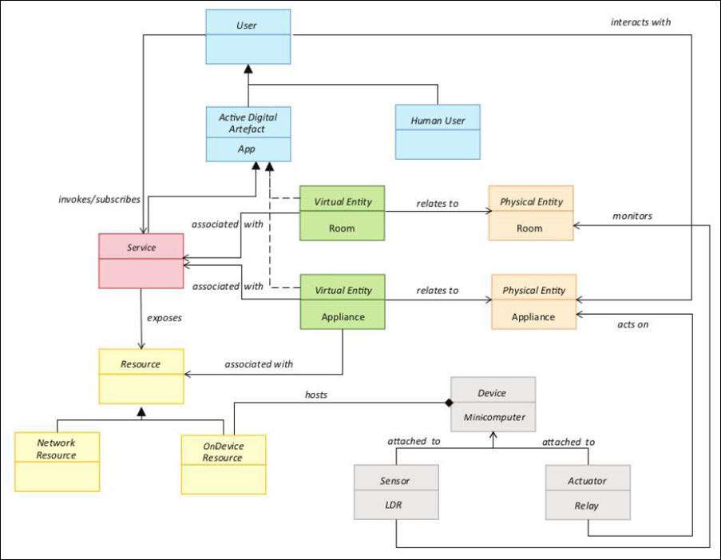
Fig 5.6 Domain model for Home automation
(Describe the domain model specification and describe the suitability for the project)
Use open source tools viz. Draw.io, Dia, or any other to draw block diagrams.
5.9 Communication model
(Based on the requirements choose the Communication model and describe the suitability for the project
The applicable communication model for the project
1. Request-response model
2. Publish-subscribe model
3. Push-pull model
4. Exclusive pair model)
e.g.
Request-Response communication model
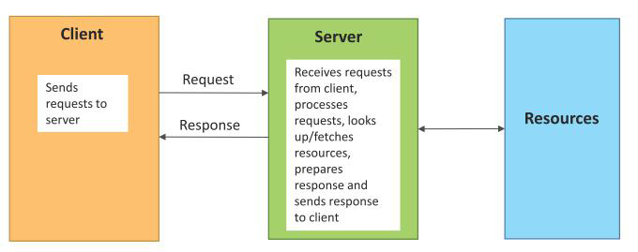
Fig 5.7 Communication model suitable for Home automation

(Describe the Communication model and describe the suitability for the project)
Use open source tools viz. Draw.io, Dia, or any other to draw block diagrams.
5.10 IoT deployment level
(Based on the requirements choose the IoT application deployment level and describe the suitability for the project
The applicable IoT deployment level for the project
1. IoT deployment Level 1
2. IoT deployment Level 2
3. IoT deployment Level 3
4. IoT deployment Level 4
5. IoT deployment Level 5
6. IoT deployment Level 6)
e.g.
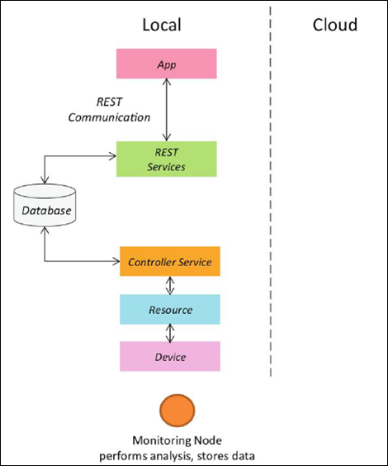
Fig 5.8 IoT deployment level suitable for Home automation

(Describe the IoT deployment level and describe the suitability for the project)
Use open source tools viz. Draw.io, Dia, or any other to draw block diagrams.
5.11 Functional view
(The functional view defines the functions of the IoT systems grouped into various functional groups. Decompose the project and describe it through the functional view
- Each functional group provides functionalities for interacting with concepts in the domain model and information related to the concepts.
- The functional groups in a functional view include: Device, Communication, Services, Management, Security, and Application.)
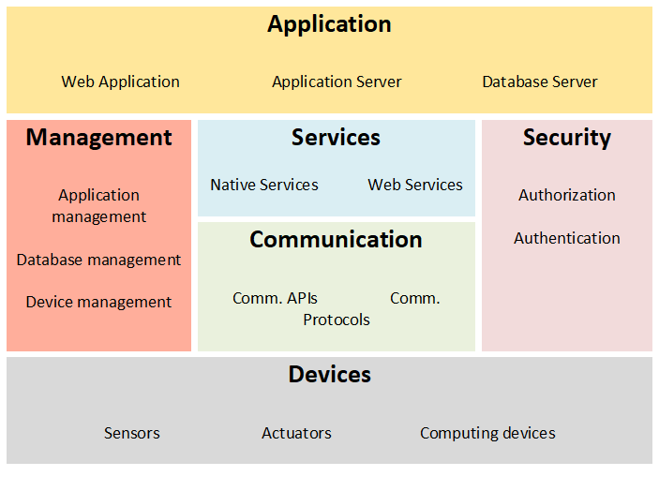
Fig 5.9 Functional view for Home automation
(Describe the functional view and describe the suitability for the project)
Use open source tools viz. Draw.io, Dia, or any other to draw block diagrams.
5.12 Mapping deployment level with functional blocks
(The mapping between the IoT level and the functional groups as suitable for the project. Describe the mapping)
e.g.
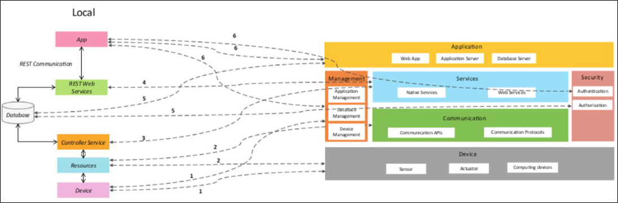
Fig 5.10 mapping IoT deployment level with functional view
(Describe the mapping between the IoT level and the functional view and describe the suitability for the project)
Use open source tools viz. Draw.io, Dia, or any other to draw block diagrams.
5.13 Operational view
(define communication options, service hosting options, storage options, device options, various options related to the IoT system deployment and operation are defined, such as:
- Service hosting options
- Storage options
- Device options
- Application hosting options)
e.g.
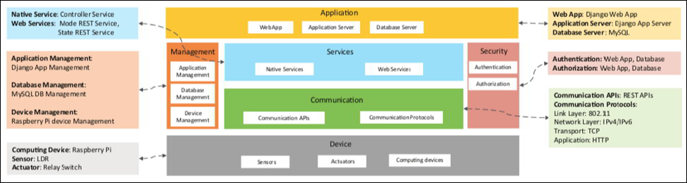
Fig 5.11 Operational view
(Describe the operational view and describe the suitability for the project)
Use open source tools viz. Draw.io, Dia, or any other to draw block diagrams.
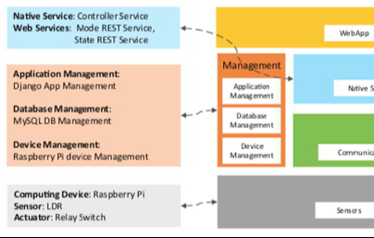
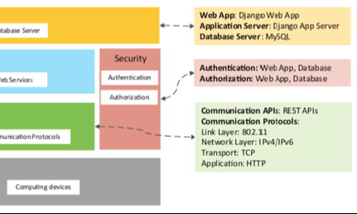
Fig 5.12 another Example of operational view

5.14 Other Design aspects
- Process specification
- Information model specification
- Service specification
- Etc.

Chapter 6
Hardware, Software and Simulation

  - Hardware
(include
- The circuit diagram and description of each sub-project or functional unit.
- The integration and description of sub-project or functional unit to realize complete project.
- The description of hardware tools required and their configuration process for development of hardware.
- Ensure proper citation and referencing.
NOTE: DO NOT insert images and description of hardware components
e.g.
- Hardware development tools for legacy MCUs.
- Debugger and Programmer tools. Debugging and programming tools and accessories.
- Reference Designs. Application-specific designs showcasing complete system solutions
- Explorer Kits. Low-cost exploratory kits - to get you started.
- Starter Kits. Modular kits for software development and feature evaluation of IoT devices.
- Radio Boards. Wireless starter kit plug-in boards featuring specific SoC or module wireless devices.
- Expansion boards. Starter kit and ecosystem accessory boards
- Evaluation Kits. Product and feature evaluation kits
- Development Kits. Full- featured application development kits
- Pro Kits. Modular kits for software development and feature evaluation of IoT devices.
- Thunderboards. Low-cost software development and prototyping kit for IoT devices)

  - Software development tools
(include the software programs and platforms tools that help streamline the software development lifecycle by automating tasks, improving collaboration, and ensuring code quality.
- Software used to create, manage, test, and deploy applications, including IDEs, version control systems, project management software, and deployment tools.
- Describe the configuration procedure of each tool as per the project requirement.
- Ensure proper citation and referencing.
NOTE: DO NOT insert images, logo and description of software
e.g.
Key Categories of Software Development Tools
Integrated Development Environments (IDEs) / Code Editors:
These tools provide a comprehensive environment for writing, editing, and debugging code.
Examples: Visual Studio Code, IntelliJ IDEA, Eclipse
Version Control Systems (VCS):
Used for tracking changes in code and facilitating collaboration among developers.
Examples: Git, GitHub, GitLab, Bitbucket
Project Management Tools:
Help teams organize tasks, manage workflows, and track project progress.
Examples: Jira, ClickUp, Trello
Continuous Integration/Continuous Deployment (CI/CD) Tools:
Automate the process of building, testing, and deploying software.
Examples: Jenkins, GitHub Actions
Containerization Tools:
Enable developers to package applications and their dependencies into portable containers.
Examples: Docker
Cloud Platforms:
Provide cloud services and infrastructure for developing, deploying, and managing applications.
Examples: Microsoft Azure, Amazon Elastic Compute Cloud
Collaboration Tools:
Facilitate communication and discussion within development teams.
Examples: Slack
API Testing Tools:
Used for designing and testing Application Programming Interfaces (APIs).
Examples: Postman
Testing Frameworks:
Tools for automating the testing of software applications to ensure quality and identify errors.
Examples: Selenium)

  - Software code
(include the code,
- Describe the function of blocks of code,
- Comment each line of code
- Ensure proper citation and referencing.)
e.g.
The software for temperature unit is as follows
The temperature sensor and standard libraries are included and variables are initialised
#include <stdio.h>
#include <dht.h>

float temp;
int tempPin = 0;
float tempCelsius = 25.0;
float tempFahrenheit = 77.0;

Two function to convert Celsius to Fahrenheit and vice versa are
// Function to convert Celsius to Fahrenheit
float celsiusToFahrenheit(float celsius) {
return (celsius * 9.0 / 5.0) + 32.0;
}

// Function to convert Fahrenheit to Celsius
float fahrenheitToCelsius(float fahrenheit) {
return (fahrenheit - 32.0) * 5.0 / 9.0;
}

The program initialise the variables and call the conversion functions to process the input values and display the results.

// Initilaise the serial monitor
void setup() {
Serial.begin(9600);
}

// Continuously monitor the temperature sensor and out the value
void loop() {
temp = analogRead(tempPin);
// read analog volt from sensor and save to variable temp
temp = temp * 0.48828125;
// convert the analog volt to its temperature equivalent
Serial.print("TEMPERATURE = ");
Serial.print(temp); // display temperature value
Serial.print("*C");
Serial.println();
delay(1000); // update sensor reading each one second

Serial .print("Temperature Conversions:\n");

// Celsius conversions
Serial.println("%.2f Celsius is %.2f Fahrenheit.\n", tempCelsius, celsiusToFahrenheit(tempCelsius));

// Fahrenheit conversions
Serial.println("%.2f Fahrenheit is %.2f Celsius.\n", tempFahrenheit, fahrenheitToCelsius(tempFahrenheit));

}

Similarly describe codes of other units and integration of the units.

  - Simulation
Simulation allows for the virtual testing of electronic circuits, microcontrollers, and complex systems, enabling developers to predict behavior, test designs, and optimize performance without physical hardware
Simulators can be used depending on project
- Circuit Simulators: Tools like LTSpice and TINA-TI provide detailed analysis of analog and digital circuits, allowing users to test component behavior and circuit performance before building prototypes.
- Microcontroller (MCU) Simulators: Software like Proteus VSM, Oshonsoft, and WOKWI simulate the operation of microcontrollers such as Arduino, PIC, and AVR, enabling the testing of microcontroller code.
- Full-System Simulators: Intel Simics is a comprehensive platform for simulating complex hardware systems, facilitating development and debugging of software for these systems.
- Hardware-in-the-Loop (HIL) Simulators: These systems (often supported by platforms like MATLAB/Simulink) test a controller's real-time response to virtual stimuli, acting as a bridge between software control and physical hardware.
- 3D Modeling and Simulation Software: Platforms such as Ansys and Fusion 360 combine design capabilities with powerful simulation tools to analyze physics-based problems like structural integrity, fluid dynamics, and thermal behavior.
Popular Software Examples
- LTSpice: A free circuit simulator from Analog Devices, widely used for analog and power electronics, offering accurate simulations and a vast component library.
- TinkerCAD Circuits: A free, web-based platform from Autodesk that is excellent for learning and simulating basic electronics and Arduino projects.
- Proteus VSM: A versatile simulator for microcontrollers, supporting various architectures like PIC, AVR, and Arduino.
- Ansys: A comprehensive suite for advanced engineering simulation, covering fields like structural analysis, computational fluid dynamics (CFD), and more.
- Intel® Simics®: A full-system simulator that allows developers to access and test complex electronic systems without needing the physical hardware.
- MATLAB/Simulink: Provides tools for modeling and simulation, with capabilities for Hardware-in-the-Loop (HIL) testing and integrating with physical systems.
Some Free Circuit Design Software
- CircuitMaker
- Open Circuit Design Software
- KiCad EDA
- ADS Circuit Design Software
- nagaEDA Circuit Design Software
- OpenSce Circuit Design Software
- QSapecNG Circuit Design Software
- SimulIde
- gerbv

Chapter 7
Evaluation and Results
7.1 Test points
- Identifying test points
- Highlight the test points in each functional unit and determine various scenarios. (trouble shooting)
- Different test points should be marked for hardware and software to check functionality.
- Determine the list of measurement (values, type of signals, etc.) at each test point.
- Each design test value should be compared with expected value, simulation and hardware for every functional unit.)
- Use open source tools viz. Draw.io, Dia, or any other to draw circuits diagrams.
e.g.
The test points are marked as V1, V2, V3, V4 and V5 for checking the required voltage levels at each of the point in functional unit automatic switching.
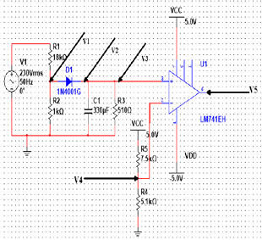
Fig 7.1 Power supply unit indicating the test points
Figure 7.1 Testing points for the automatic switching. …..
Example of test scenarios for a project related to solar panels
o First scenario or test plan should test the output with various considerations. Test the output of the solar panel at different levels and calculate the potentiometer adjustment theoretically.
o Second scenario or test plan 2 in this stage calculates the voltages for the interfaces connected.
Test point 3 or scenario 3…
7.2 Test plan
- Develop test plan Develop the test plan for each functional unit.
- The test plan should be in the form
<Subject> <verb> <Object> <conditions> <values> <range> <constraints>
- Develop the test cases for measuring various system characteristics and performance such as accuracy, linearity, latency, power aware etc.
  - Black box testing (positive, negative, boundary)
  - White box testing (Control flow, Data flow, Branch, Path)
  - Hardware testing
  - Unit Testing
  - Integrated testing
  - Software testing
  - System testing
  - Validation (dynamic, testing user requirements)
e.g.
TP1: The voltage must be 3.25V when the input is varied between 4 to 6V.
TP2: Measure output voltage of temperature sensor for range of temperature
TP3: Measure the output voltage of the IR sensor for detecting object and distance.
TP4: for various input value at ADC pin of microcontroller display the value in serial terminal.
Tp5: for each value of ADC pin of microcontroller compute the Temperature and display the temperature in serial terminal.
TP6: Send initialization commands LCD and test it turn ON
TP7: Send char in serial port to WiFi and check output.

7.3 Test Result
- Tabulating test results.
- (For all the test case scenarios listed with respect to design, simulation and implementation aspects.
- Measure the sensed values for a range, represent data in tabular form, visualize using graphs, and describe the interpretations
- Measurement of various system characteristics and performance such as resolution, efficiency, errors, accuracy, linearity, latency, power aware etc. also
- should be tabulated with detailed description.)

Table 7.1 Observations of the Temperature unit
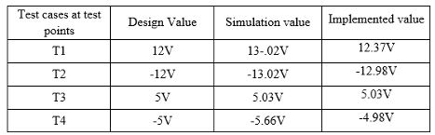
Observations:
Table 7.2 include Observations for each unit
Input | Computed value | Simulated value | Analog value | Digital value

- Reflect on observations.
e.g.
Referring to the table 7.1 it observed that the simulation values are very close to the actual values which reflect the proper functioning of real prototype to meet the objectives. The error is less than 10% and the accuracy of the output is within 90%
Visualise the results with appropriate graphs and describe the insights.
e.g.
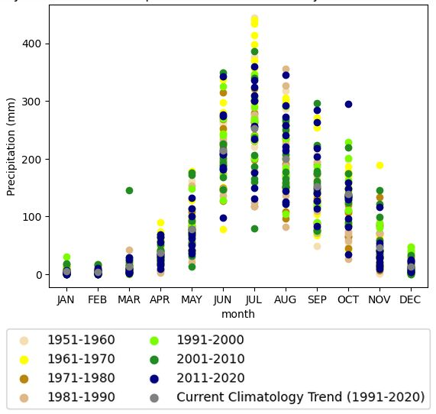
Fig 7.2 Variability and trends of precipitation across seasonal cycle of Karnataka region
Fig. 7.2 shows the variability and trends of precipitation across seasonal cycle of Karnataka region for the period 1951-2020 to observe the change in precipitation of each month over the years. Precipitation is usually high in the monsoon month of July and low in the non-monsoon month of December, being highest during period 1951-1960 and lowest in the period 2001-2010. Comparing the average trend values of the latest decade 1991-2020 with earlier decades, the precipitation values are lower in recent decades compared to earlier years indicating climatology trend of precipitation decrease over the years.
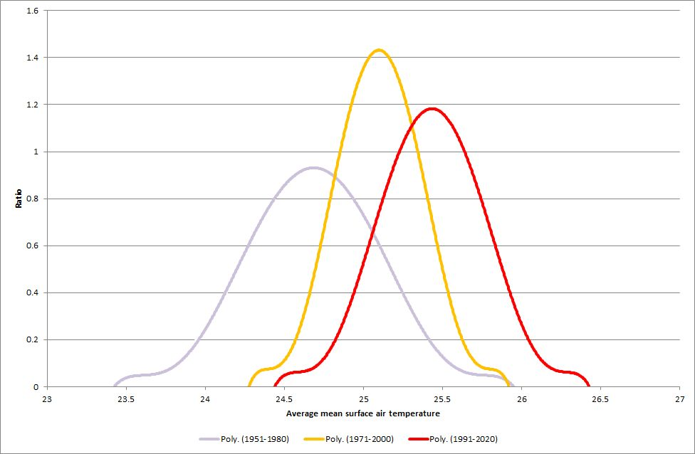
Fig. 7.3: Distribution of Average mean surface air temperature of Karnataka region.
Fig. 7.3 shows change in distribution of average mean surface air temperature of Karnataka region for three periods 1951- 1980, 1971-2000 and 1991-2020. It is observed the peaks have shifted 24.50C, 25.150C and 25.60C respectively indicating increase 1.10C in temperature value compared to the previous period. Moreover, the shift does not only signify increase in the peak but also the range of temperatures in later periods. The distribution suggests that the higher temperature event is more often than before.
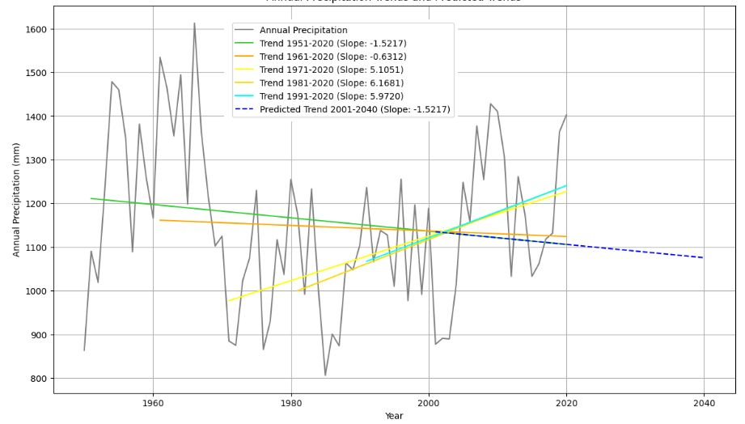
Fig. 7.4: Trend line of Precipitation per decade of Karnataka region.
Fig. 7.4 shows the Trend line of the Precipitation per decade of Karnataka region. The annual average mean precipitation values have gradually fluctuated over the period of 1951-2020. Although the recent years 1971-2020, 1981-2020 and 1991-2020 shows an increasing precipitation, there is a decreasing trend compared to the previous period of 1951-2020 and 1961-2020. The trend line 2001 to 2040, is directed downward predicting a decrease in the precipitation.
Other examples of graph
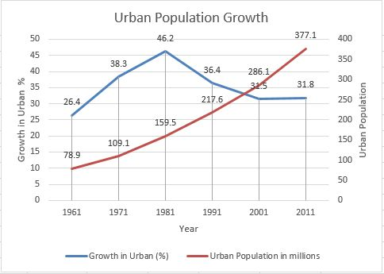
Fig. 7.5 Fig. 1: Urban population and rate of growth of urban population [1].
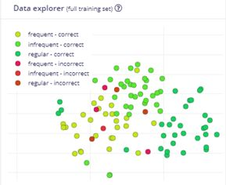
Fig. 7.6: Data explorer view of correct and incorrect predictions.
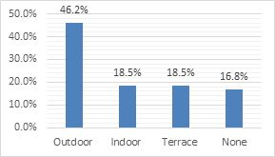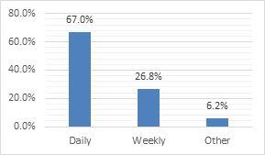
(a) Type of garden owned. (b) Watering frequency of plants.
Fig. 7.7: Garden owned and frequency of watering plants
Provided insights for each figure, graph, table

7.4 Insights
Discuss insights. Give reasons for the problem
e.g.
- What was the reason for the component getting burnt?
- What are the conditions under which some components do not work?
- Discuss the evaluation in terms of working principle, signal conditioning, latency, linearity, resolution, efficiency, error, accuracy etc.
e.g.
- The regulator provides current 1.3A which is close to the maximum rating and gets heated. To avoid exceeding ratings the current may be driven using regulator of higher rating, using heat sink to avoid burning, or multiple regulators to distribute currents to different devices.
- The microcontroller requires 200ms to return from sleep state but the delay does not affect the measurement as temperature variation is slower.
- As per datasheet the minimum voltage the 10 bit ADC of the microcontroller can measure is 4.89mV and lower values cannot be measured with precision. A high precision ADC would be required for measuring smaller values.
- The maximum output voltage of solar panels is 18V that can damage the input to microcontroller and requires interfacing circuits to shift level below 5V to avoid damage to microcontroller.
- The measurement of distance by ultrasonic sensor is 34cm whereas the actual value is 31cm which is within 10% accuracy. Ultrasonic sensors are affected by oil, humidity and heat, thus affecting the readings and their instability.
- The current sourced by microcontroller digital pin is 40mA and DC current between Vcc and Ground is 200mA. It cannot be used to drive the relay that requires 100mA current and so relay drivers ULN2003 are required. It cannot drive the DC motor and L298N is used
- The accuracy between the design, simulation and implementation values is within 10% Although the error is 2% in measurement of time it is not cumulative and remains constant for all values.
Discuss the aspects to improve each functional units in terms of reliability, power aware, interrupt driven, precise timing, meeting standards, safety etc.
e.g.
- The switch allows system configuration in OFF mode and normal operation in ON mode.
- Interrupt driven programming is used. The microcontroller is programmed to sleep state. When an event occurs an interrupt is generated to wake the system. The measurement and processing is completed and once again the system is put to sleep mode. The power in wake mode is 6.5mW and 2uW in sleep mode, thereby saving power. The event occurs every 500ms but It takes 100ms to wake, so no value is lost.
- The standard frequency 2.4GHz is the used for communication
- The freewheeling diode is connected across the relay coil to avoid damage to circuit.
- The system has a power switch and reset switch to provide safety and power saving when not in use.
- One possible solution is to change the ultrasonic sensor with the waterproof ultrasonic sensor.

Chapter 8
Social, Legal, Ethical, Sustainability and Safety aspects

The actions that society finds acceptable versus the actions which society do not accept.
Unfortunately, not all situations are morally well defined.
- Who is responsible for assuring the safe, legal, and ethical use of this project?
- What are the consequences of dishonesty in system/project use, individual and professional?
- How does ethical analysis apply to activities that are against the law?
- Ensure proper citation and referencing.

8.1 Social Aspects
Social aspects address how a technology or product affects society, including human interactions, communities, and culture.
- Ensure proper citation and referencing.
e.g. impact of AI
Positive impacts: Enhanced communication through social media and messaging, improved healthcare with advancements like telemedicine, and broader access to information and education via online platforms.
Negative impacts: The digital divide, which exacerbates inequality by leaving those without access to technology behind. Social media can also contribute to social isolation, mental health issues, and cyberbullying.
Case study: AI: The social impact of Artificial Intelligence (AI) includes changes to the workforce due to automation, the potential for algorithmic bias to reinforce societal inequalities, and challenges to human dignity if AI replaces roles that require empathy, such as caregiving or counseling.
8.2 Legal Aspects
Legal aspects concern regulations and compliance, with a strong focus on data privacy in the digital age.
- Ensure proper citation and referencing.
e.g. impact of AI
Data privacy laws: Landmark legislation such as the EU's General Data Protection Regulation (GDPR) and India's Digital Personal Data Protection Act (DPDPA) of 2023 establish frameworks for handling personal data. Key principles include lawful and fair processing, purpose limitation, data minimization, and accountability.
Rights and obligations: Under such laws, individuals have rights to access, correct, and erase their personal data. Data fiduciaries (those who process data) are obligated to obtain consent, implement security safeguards, and manage grievances.
Challenges: Regulatory compliance is complex for multinational companies. For technologies like autonomous vehicles, determining liability in the event of an accident presents a new legal challenge.
8.3 Ethical Aspects
Ethical aspects involve moral principles guiding the development and use of technology, considering fairness, accountability, and potential harm.
Ethical action on the part of engineer can be partially simplified, as the simple mandate that an engineer's greatest responsibility is to the public good.
- What effects have your project had on the quality of life in the workplace, and in society in general?
- Are your projects addictive?
- Do they depersonalize the individual to the point that ethical issues no longer seem relevant?
- How do electronics engineering professionals determine ethical standards to deal with the effects that their work has in these areas?
- Ensure proper citation and referencing.
e.g. impact of AI
AI ethics: This field addresses issues like algorithmic bias and fairness, which can arise when AI is trained on skewed data, leading to biased outcomes in areas like hiring or criminal justice. Other key concerns include transparency (the "black box" problem), data privacy, and accountability.
Robotics: Ethical questions also surround robot rights, the use of AI in lethal autonomous weapons, and how to program morally sound decision-making into autonomous systems.
Generative AI: Ethical debates also encompass copyright and intellectual property, as generative AI models are trained on existing human-created content.
8.4 Sustainability Aspects
Sustainability aspects relate to the environmental impact of a product or process, especially throughout its lifecycle.
Sustainable design is a kind of design meant to yield products that are made only of renewable resources. Furthermore, products made, though sustainable design is intended not to seriously impact the environment either when they are being created or when they are being used. These products are also often designed to allow the users to feel more connected or to relate more closely to the natural environment. This design is based on economic, ecological, and social principles regarding the importance of sustainability.
Discuss the relevant sustainability aspects of your project by answering some of the principles (but not restricted to these principles only) of sustainable design as follow:
  - Efficient use of raw materials (e.g. lightweight and regenerative materials and reduction of waste)
  - Resource efficient design (e.g. by optimization of energy and water consumption or using less virgin materials)
  - Durable design (e.g. stable and high durability of the product)
  - High disposability (e.g. use of easily degradable materials)
  - Efficient logistics (e.g. minimized packing and efficient transports)
- Consumer health & safety (e.g. informing the consumer via product labels and voluntary information
- Ensure proper citation and referencing.)
e.g. impact of AI
Supply chain sustainability: Businesses are increasingly focused on creating sustainable supply chains by adopting ethical sourcing, using renewable energy, and managing waste. Measures include reducing emissions from transportation, designing products for recyclability, and establishing transparency with suppliers.
Environmental considerations: The goal is to minimize environmental harm, including protecting natural resources and reducing greenhouse gas emissions. Technologies like AI and advanced analytics are being used to optimize supply chains and promote circular economy principles.
Social dimension of sustainability: A sustainable approach also incorporates social responsibility, ensuring fair labor practices and safe working conditions throughout the supply chain.
8.5 Safety Aspects
Safety aspects focus on preventing harm and ensuring the security and reliability of products and systems.
(Discuss and describe the safety aspect from the perspective of the project
- Ensure proper citation and referencing.
e.g.
The Internet of Things (IoT) in Health, Safety, and Environment (HSE) refers to the application of connected physical devices, sensors, and network technology to optimize and enhance processes related to occupational health, workplace safety, and environmental management. This integration enables real-time data collection, facilitating informed decision-making and promoting safer and more sustainable practices.
IoT safety is the process of protecting IoT devices, networks, and data from threats by using best practices like strong, unique passwords and multi-factor authentication, regular firmware updates, data encryption, creating isolated networks for IoT devices, and monitoring for suspicious activity.
IoT also improves safety by enabling real-time monitoring of environmental hazards, providing data-driven insights for risk prevention, and improving emergency response through alerts and guided evacuations.)
e.g. impact of AI
Autonomous vehicles: Safety is paramount for self-driving cars, requiring robust sensor suites, extensive software testing, and cybersecurity measures to prevent hacking. Redundancy and fail-safe mechanisms are built in to ensure functional safety.
AI systems: Safety guidelines are also crucial for AI, including developing systems that are robust and reliable under various conditions and implementing continuous monitoring. The goal is to prevent AI from producing harmful or unintended outputs.
Cybersecurity: This is a key component of safety, particularly in technology. It involves protecting systems from cyberattacks, data breaches, and unauthorized access.

Chapter 9
Conclusion
(Summarise the approach used in the project, the results obtained and future work)
- Discuss how the implementation of this project meets the objectives listed in the Introduction.
- Summarize the results and link it with the objectives of the project
- Future recommendation - Reflect on design aspects that can be improved but not implemented in your project.)
e.g.
Solar tracking systems designed in the proposed work fulfills the optimized structure in different scenarios based on sunlight. The designed prototype is IoT based to monitor and control the system and also serves as an efficient and a sustainable solar tracking device…….
In the future, this project can be developed and improved to make it more efficient and usable by......

References
(When you write a research paper or report, including a list of references is an important step. Below are some guidelines for selecting and formatting your references.
Include references of all sources used in chapters – 1. Introduction, 2. Literature review, 3. Methodology, 4. Project management, 5. Analysis and Design, 6. Hardware and Software implementation, 7. Evaluation and results, and 8. Social, Legal, Ethical, Sustainability and Safety aspects.
Reference Selection
- Make sure all references are directly relevant to the topic/project.
- You should cite recent conference and journal papers, preferably those published within the last three to five years.
- If you include any figures or tables from other sources, they must be properly cited as well.
Citation and Formatting
- Every source you cite in the body of the report must appear in your reference list,
- Every source in your reference list must be cited in the text.
- If you cite a source multiple times, you only need to include one entry for it in your reference list.
- Finally, do not include any references in your list that you haven't cited in your paper.
Use Havard style – e.g. author name, year, title of paper, conference or publication, vol, issue, page no, ISBN no …
e.g.
[1] United Nations, Sustainable Development Goals, Department of Economic and Social Affairs UN, https://sdgs.un.org/goals
[2] NarasimhaRao, Y., Chandra, P.S., Revathi, V. and Kumar, N.S., 2020. Providing enhanced security in IoT based smart weather system. Indonesian Journal of Electrical Engineering and Computer Science, 18(1), pp.9-15.
[3] Raju, M.P. and Laxmi, A.J., 2020. IOT based online load forecasting using machine learning algorithms. Procedia Computer Science, 171, pp.551-560.
[4] ….
Do not summarise from websites, wikipedia, blogs, etc.)
Base Paper
(From References the mainly referred paper)
Use the instructions below to format your references to match the example in the "References" section above.
Step 1. Visit https://scholar.google.com/
S

